*Project Name [****HOTEL MANAGEMENT SYSTEM****]*

**Table of Contents:**

Chapter 01: **INTRODUCTION**

Chapter 02: **SCENARION DESCRIPTION & CASE STUDIES**

Chapter 03: **ER DIAGRAM** **&** **SCHEMA DIAGRAM**

Chapter 04: **FEATURES LIST AND FUNCTIONALITIES**

Chapter 05: **SCREENSHOT OF TOTAL PROJECT**

Chapter 06: **SQL QUERY**

**Introduction**

The **Hotel Management System (HMS)** is a comprehensive digital platform designed to streamline hotel operations by automating processes such as bookings, payments, room assignments, maintenance reporting, and leave requests, while providing role-based access control for admins, customers, staff, and receptionists. Leveraging a centralized database for real-time updates, the system ensures seamless operations and instant access to up-to-date information. Key features include secure transaction processing, customizable dashboards, and automated notifications for booking confirmations, maintenance updates, and leave approvals, all of which enhance operational efficiency, reduce errors, and improve guest satisfaction. Ideal for modern hospitality businesses, the HMS offers a scalable, organized, and user-friendly solution that boosts productivity, optimizes resource allocation, and elevates both staff efficiency and the overall guest experience.

**Scenario Description**

The **Hotel Management System (HMS)** optimizes guest and staff interactions by automating workflows. When a **customer** books a room, the system immediately confirms availability, processes the payment, and updates the booking status to reserve the room. **Staff** can report any maintenance issues, which automatically trigger alerts to **administrators.** The administrators then assign tasks and monitor their resolution progress. **Receptionists** manage check-ins by confirming bookings and payments, and update room statuses accordingly. They also initiate cleaning procedures during check-outs.

**Administrators** oversee all operations, including approving leave requests to ensure adequate staffing levels. The system ensures that all modules, from room assignments to payment processing, are synchronized in real-time, and it enforces role-based access control for every stakeholder. Notifications are sent to keep everyone updated on booking confirmations, maintenance status, and leave approvals.

By digitizing traditionally manual processes, the HMS reduces errors, speeds up processing times, and improves operational efficiency. It enhances resource allocation, increases staff productivity, and boosts guest satisfaction with a responsive, user-friendly interface and centralized database management.

The HMS ensures seamless and intuitive processes: **customers** easily browse and book rooms, **staff** promptly report and resolve maintenance issues, **receptionists** efficiently handle check-ins and check-outs, and **administrators** maintain full oversight. With real-time data access, the HMS sets a new standard for accuracy and efficiency, creating significant value for both guests and hotel management.

**Case Study: Successful Implementation of Hotel Management System (HMS)**

A mid-range hotel faced challenges in managing high booking volumes, ensuring room availability, and improving staff communication. To address these, the hotel implemented the **Hotel Management System (HMS),** which automated key processes like room bookings, payment processing, and room assignments, ensuring seamless operations and real-time synchronization across departments.

With the HMS, receptionists efficiently managed check-ins, check-outs, and room status updates in real time, reducing delays and preventing overbooking. The system’s dashboard displayed booking ID, guest details, and room assignments, streamlining operations. Receptionists could also cancel or modify bookings quickly, enhancing guest satisfaction.

For **housekeeping staff,** the system enabled room assignments, maintenance tracking, and task management. Staff could mark rooms as cleaned and report maintenance issues, triggering automatic alerts to **administrators,** who monitored progress and resolved issues faster.

Administrators gained better control with dashboards displaying critical stats like daily revenue, room occupancy, and bookings. They could approve leave requests, ensuring the hotel remained adequately staffed, and generate revenue reports for better pricing and strategy optimization. The system also provided secure payment options (Card, Bkash, Rocket, Nagad, Bank Transfer) and automated PDF receipt generation for both customers and the hotel’s record-keeping.

The HMS enhanced customer experience with a review system, allowing guests to rate their stays and book additional services like the pool, spa, and buffet. By digitizing manual processes, the HMS reduced errors, improved resource allocation, and boosted staff productivity.

Overall, the **HMS** transformed the hotel’s operations, improving operational accuracy, reducing manual tasks, and enhancing guest satisfaction, making it an ideal solution for hospitality businesses seeking efficiency and scalability.

**Features List**

### ****1. User Authentication & Management****

* **Registration**: New users can sign up with name, email, phone, and password.
* **Login**: Role-based login (Customer, Receptionist, Staff, Admin).
* **Password Recovery**: Forgot password functionality via email and phone verification.
* **Profile Management**: Users can view and edit their personal information.

### ****2. Customer Features****

* **Room Booking**:
  + View available rooms with images, descriptions, and pricing.
  + Filter and sort rooms (alphabetically, price low-high, price high-low, Booked, Available ).
  + Select check-in/check-out dates.
  + Confirm bookings with payment.
* **Booking Management**:
  + View booking history.
  + Cancel bookings.
* **Multiple Payment**:
  + Card/Bkash/Rocket/Nagad/Bank Transfer
  + Generate OTP
  + Secure payment processing.
  + Generate and download PDF receipts.
* **Write a Review**
* Rating System
* Comment section
* Review Submission
* Booking Verification
* **Hotel Facilities :**
  + Browse amenities like pool, buffet, and spa with brief descriptions.
  + Transparent per-person pricing shown.
  + Easy booking via “Book Now” for each facility.
* **Edit Info & Unpaid Pay Bill**
* Easily update your details
* View and manage unpaid bills through a user-friendly online portal.

### ****3. Receptionist Features****

* **Booking Management**:
  + View all active bookings.
  + Update booking status (Booked → Check-In → Check-Out).
  + Remove bookings if needed.
* **Leave Application**:
  + Apply for leave with dates and reason.
  + View leave request history and status.
* **Dashboard View**:
* Booking ID
* Name
* Email
* Room Number
* Check-In and Check-Out dates
* **Sorting Options**:
* Default Sorting
* Check-In
* Paid
* Pending
* Booked
* Check-Out
* **Profile Features:**

Profile Overview**:** Displays and allows editing of

* Name
* Email
* Phone Number

Tabs :

* + **Salary Info**: View salary details.
  + **Additional Info**: Displays extra relevant information.
  + **Leave Info**: Shows leave history, remaining leave, and statuses (Pending, Approved).

### ****4. Staff Features****

* **Staff Dashboard**
* **Description**: Displays the staff's tasks for the day, showing assigned rooms, status (cleaned/dirty), and assigned dates.
* **Room Assignments**:
  + View assigned rooms and cleaning status.
  + Mark rooms as cleaned.
* **Maintenance Requests**:
  + Report room maintenance issues.
* **My Tasks :**
* A list of tasks assigned to the staff with options to mark tasks as completed. Includes an option to report room issues.
* **Staff Profile**
* Displays the staff's profile with personal information, job details, and the option to edit the info. Includes tabs for additional info, salary, and leave details.
* **Salary Info:**
* Shows the staff's salary details, including salary amount, allowances, deductions, bonuses, and net salary. Also provides the last salary date and payment method.
* **Leave Management**:
* A list of tasks assigned to the staff with options to mark tasks as completed. Includes an option to report room issues.

### ****5. Admin Features****

* **Dashboard Overview**:
* **Key Statistics**: Displays important data like Today's Check-Ins, Total Bookings, Occupied Rooms, and Today’s Revenue.
* **Recent Check-ins & Check-outs**: Shows the latest check-ins and check-outs with customer details, room numbers, and booking dates.
* **Leave Request Handling**:
  + Approve or dismiss staff/receptionist leave requests.
* **Maintenance Management**:
* **Room Details & Price**: Displays the list of rooms with their types, prices, and the option to update them.
* **Maintenance Issues**: Tracks issues in rooms, their status (pending, in progress, completed), and provides the ability to mark them as resolved.
* **Revenue Report**:
* Generates a revenue report showing daily ,monthly,yearly,bookings and revenue. Allows for the selection of a date range and report type.
* **Customer Reviews**:
* **Customer Feedback**: Displays reviews with ratings, comments, and the option to delete selected reviews.
* **Facilities Bookings**:
* **Facility Reservation**: Manages facility bookings (e.g., swimming pool, spa), showing the booking status (pending, confirmed, completed), guests count, and total price. Admin can update the status.
* **Booking Reports Enhancement**:
* **Check-In & Check-Out Dates**
* **Customer Details:**
* **Room Details**
* **Booking Amount**
* **User Management**:
  + (Add/remove users (staff, receptionists).
  + Update salary
  + Add Bonus

### ****Technical Features****

* **Database Integration**:
  + SQL Server for storing user data, bookings, rooms, etc.
* **Dynamic UI Generation**:
  + Rooms, bookings, and assignments displayed in dynamically generated panels.
* **PDF Receipt Generation**:
  + iTextSharp for creating payment receipts.
* **Role-Based Access Control**:
  + Different dashboards for customers, receptionists, staff, and admins.
* **Responsive Design**:
  + Adjusts UI elements based on screen size.

### ****Additional Features****

* **Room Details**:
  + View room images, amenities, and features.
* **Search Functionality**:
  + Search rooms by type.
* **Date Validation**:
  + Prevents booking conflicts by checking room availability.

**Schema Diagram**

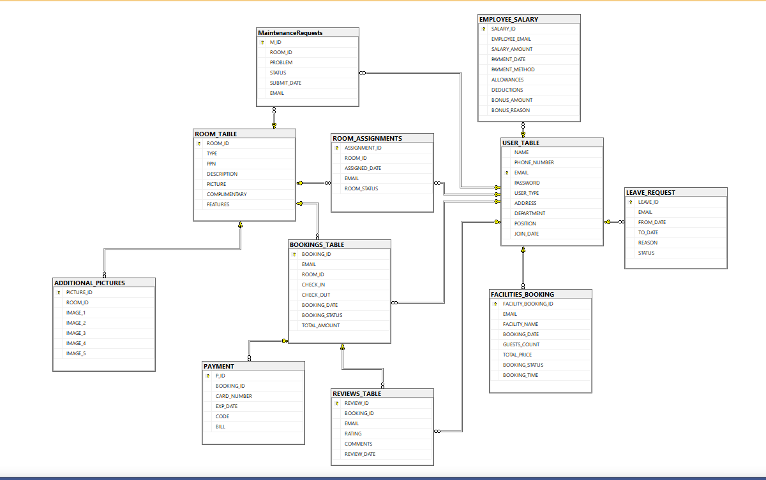

**ER DIAGRAM**

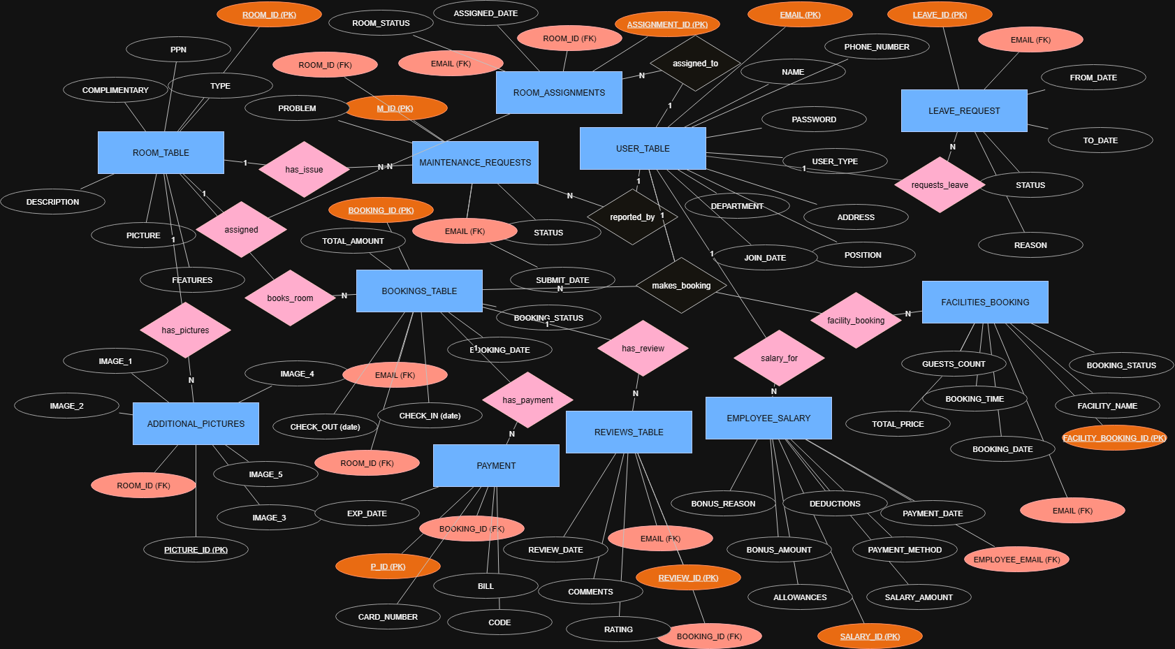

**Conclusion**

This hotel management system efficiently streamlines operations for customers, staff, receptionists, and administrators. With secure authentication, dynamic booking, payment processing, and role-based dashboards, it enhances user experience and operational efficiency. The system ensures smooth coordination between departments, improving service quality and management. Future enhancements could include AI-driven recommendations and mobile app integration for greater accessibility.

Home Page:

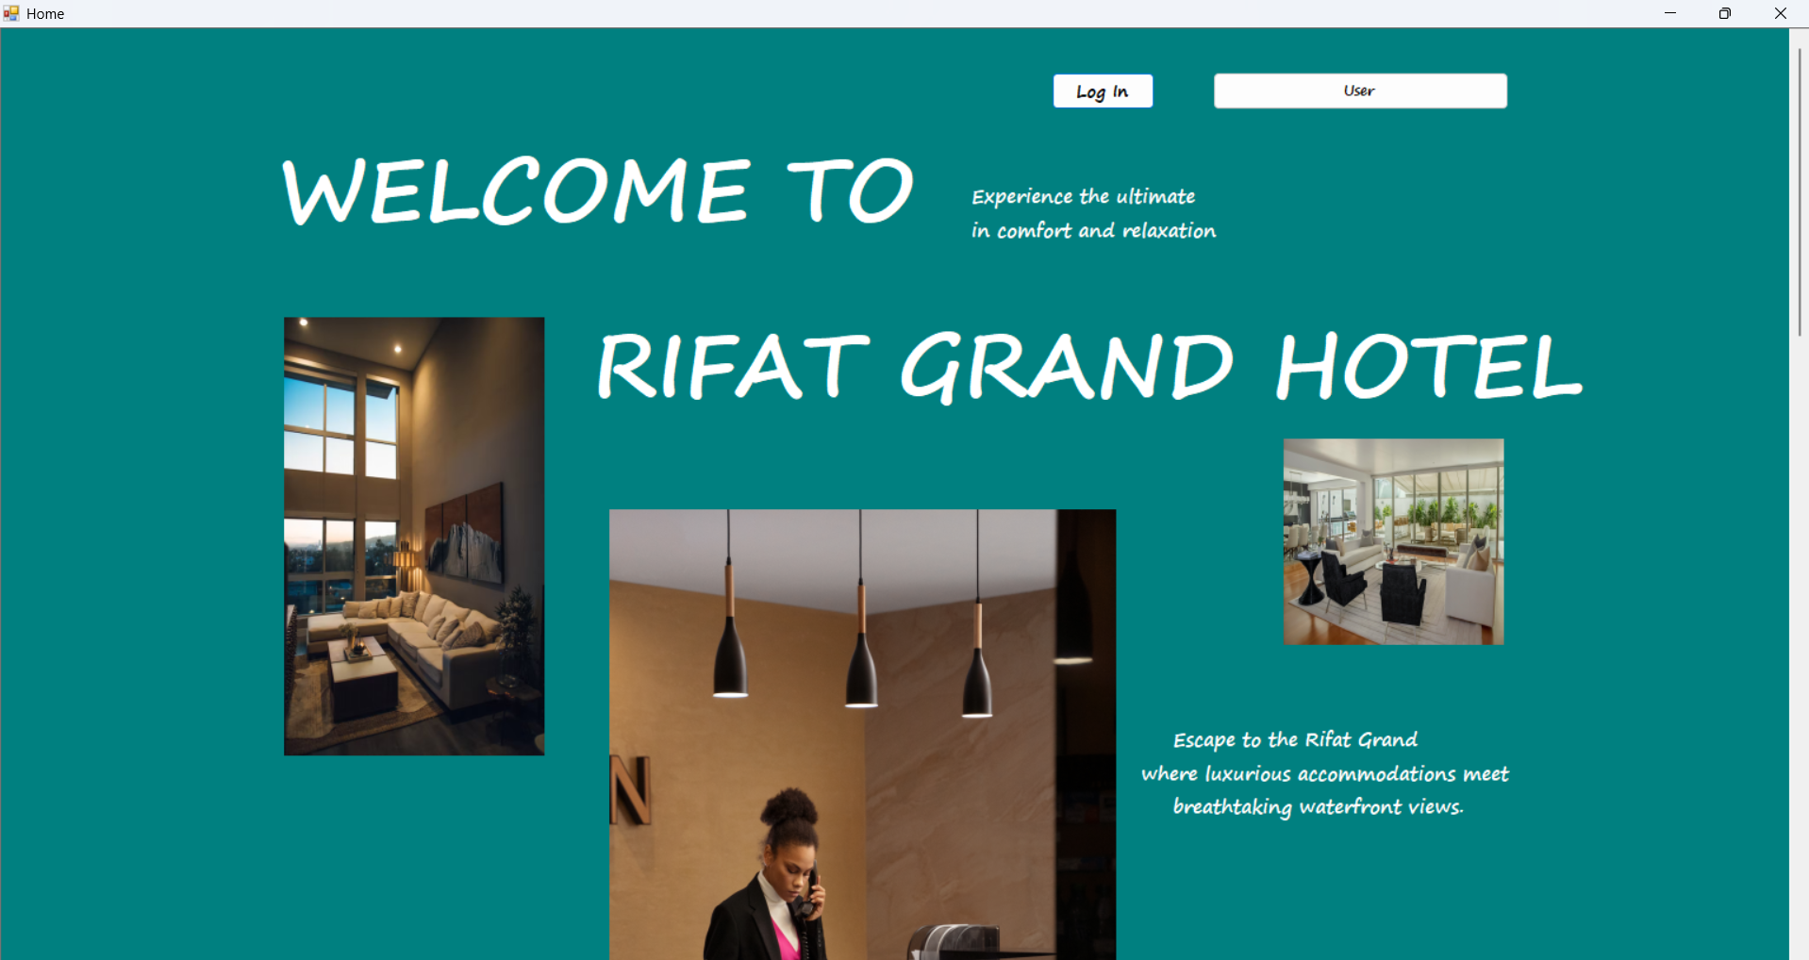

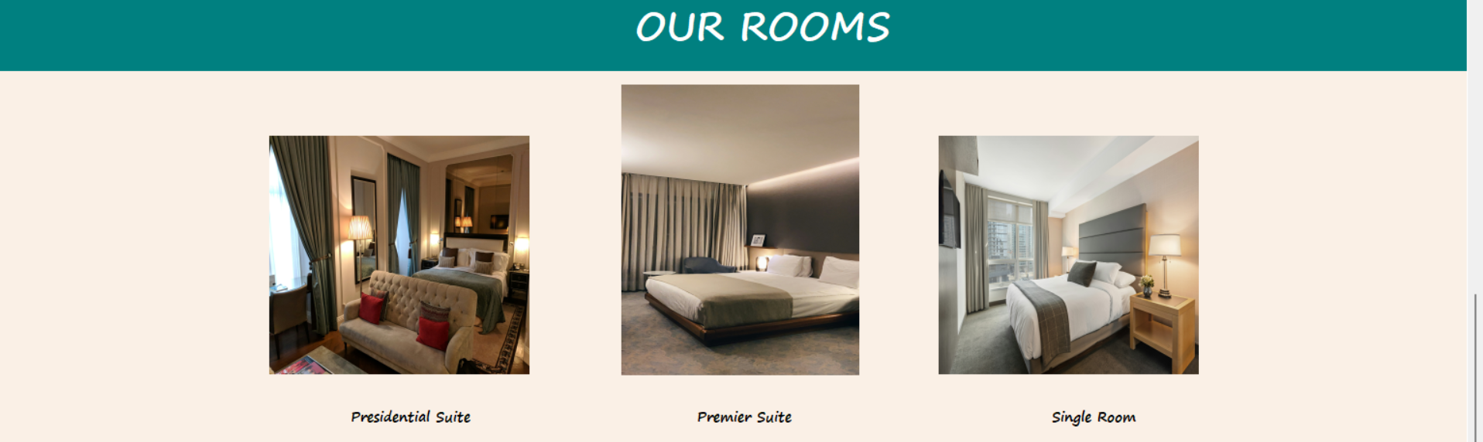

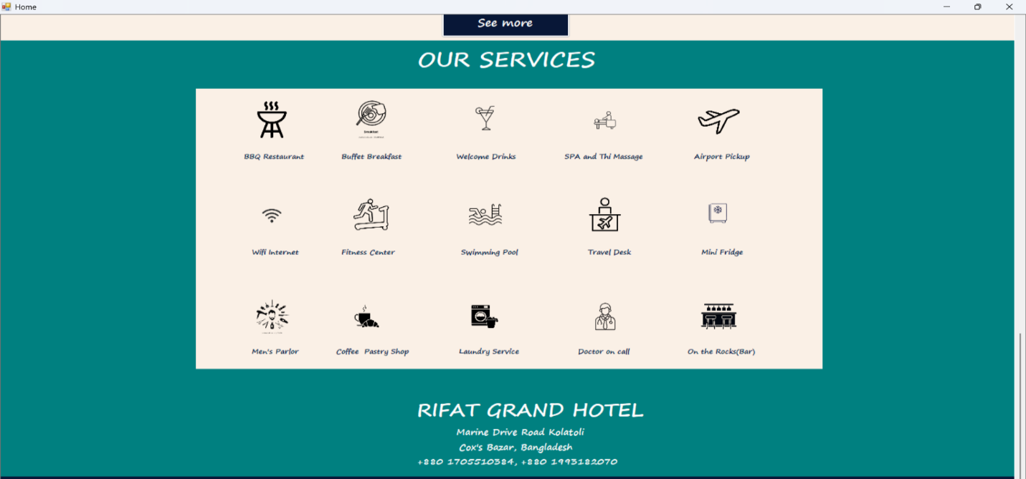

Login Page :

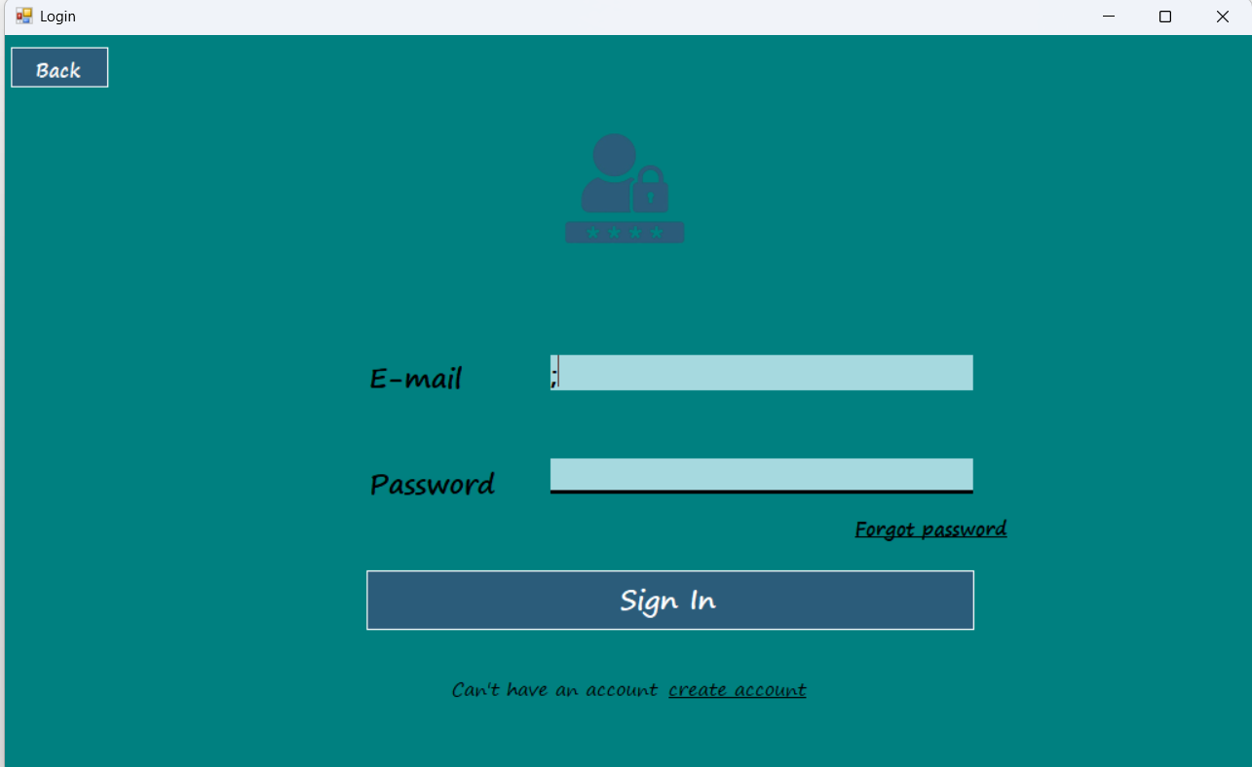

Signup Page/Registration :

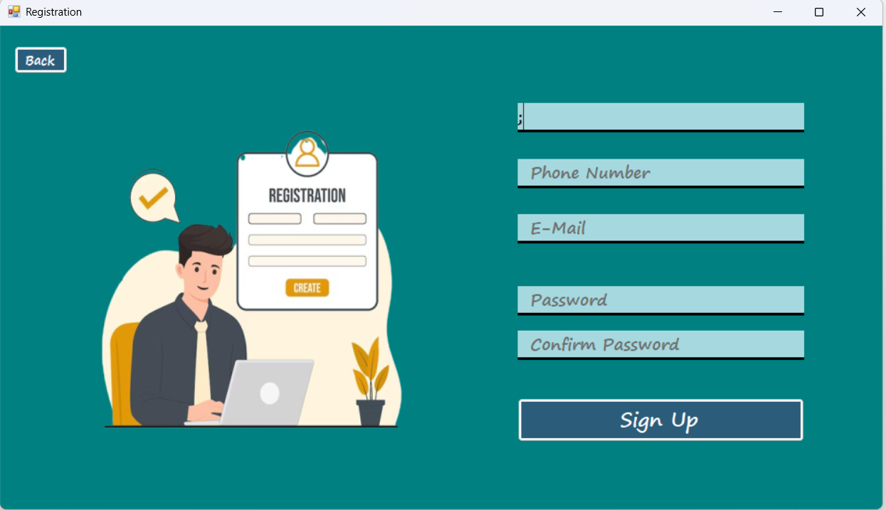

Forgot Password Recovery Page :

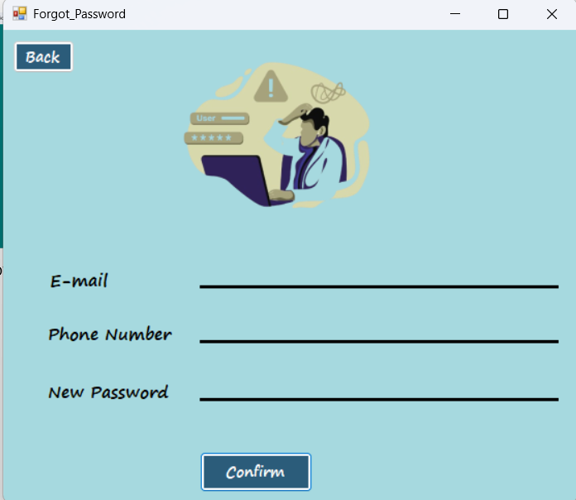

ADMIN DASHBOARD :;

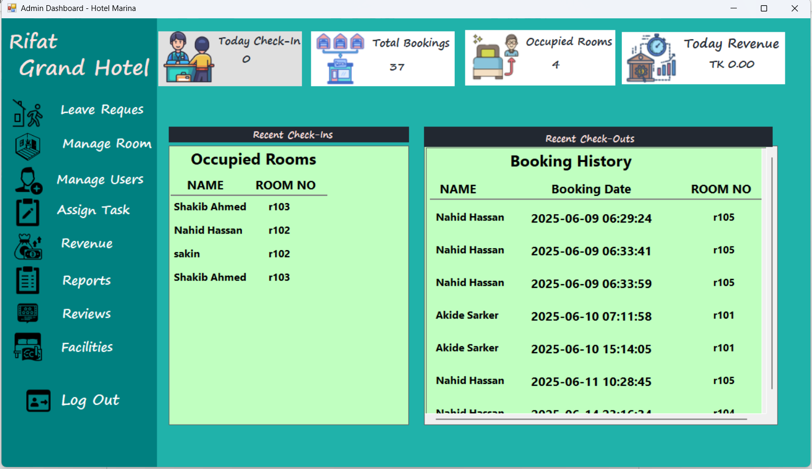

Leave Request Form:

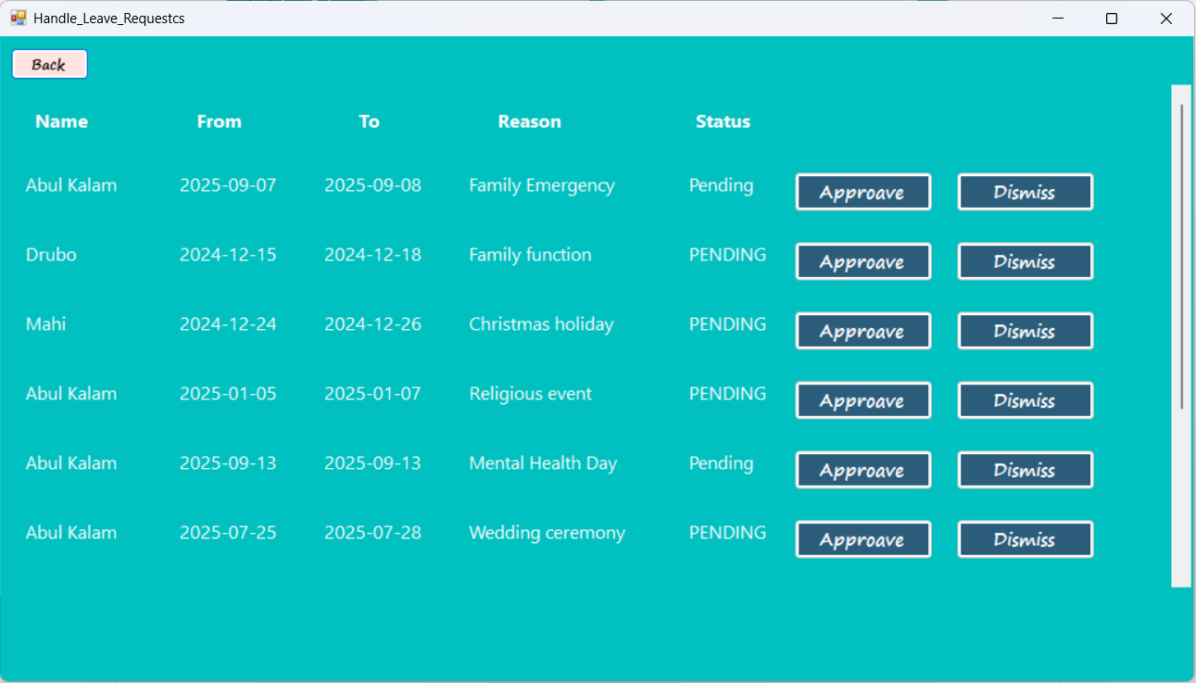

Manage Room Form :

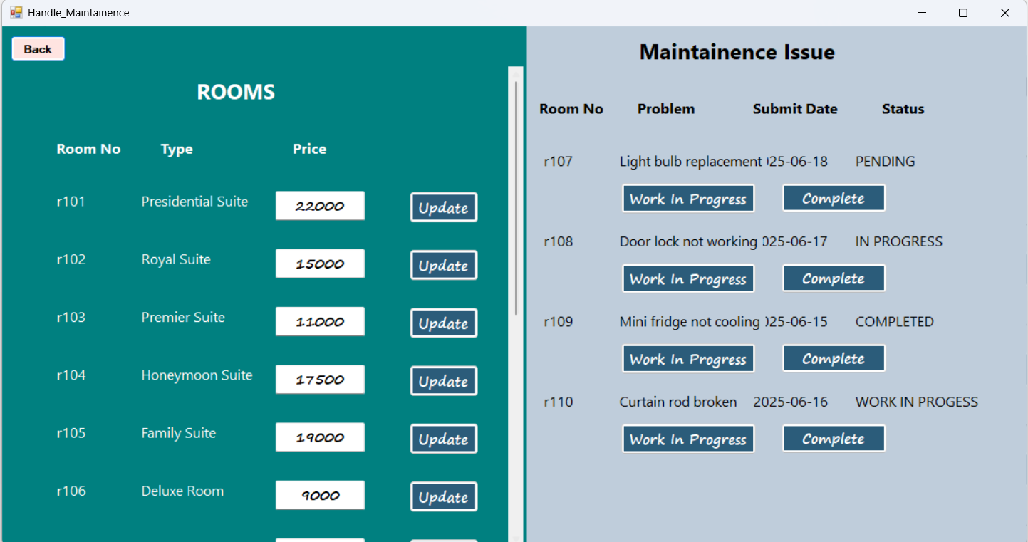;

User Management Form :

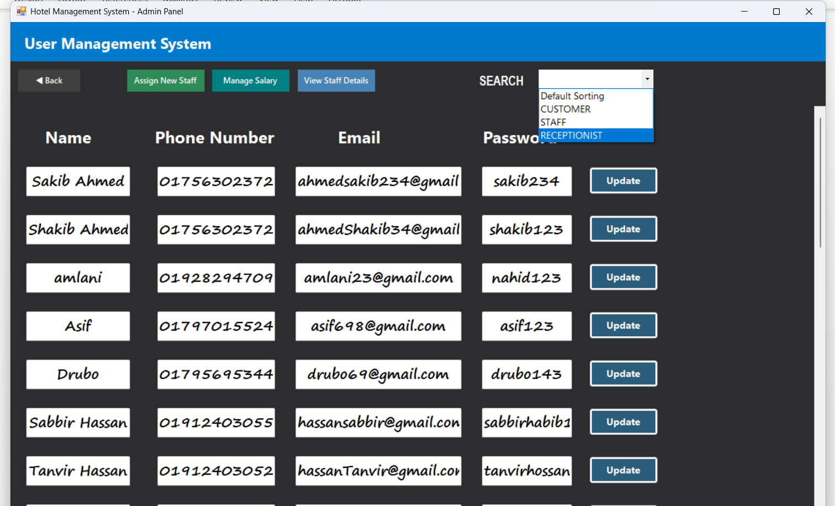

User Management Form (**Assighn New Staff**):

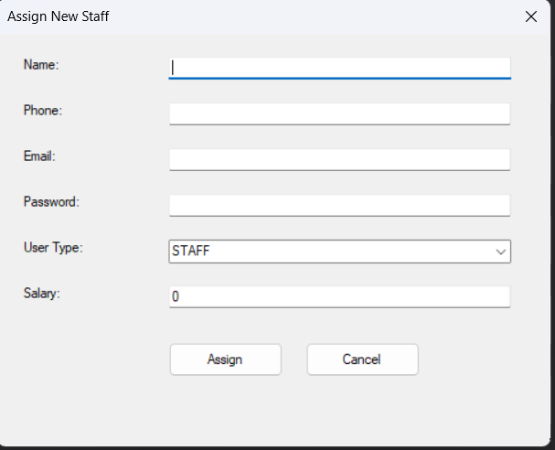

User Management Form (**Salary Management**):

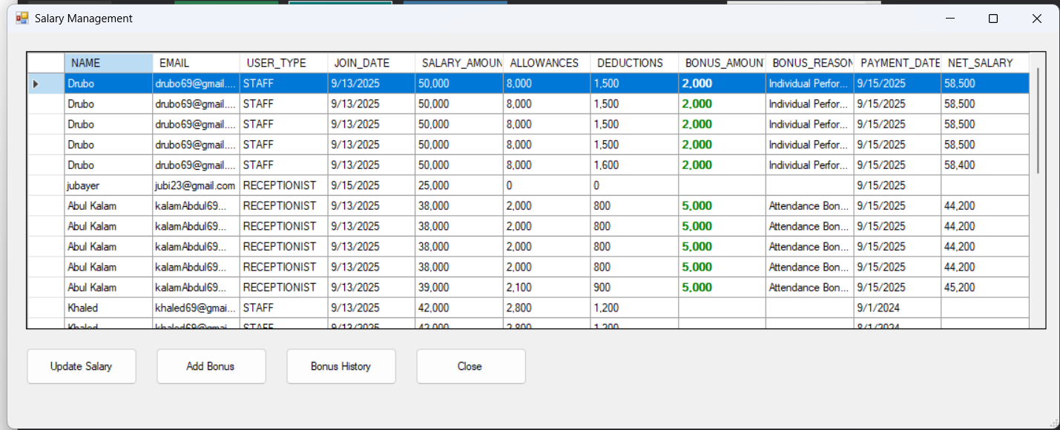;

User Management Form (**View Staff Details**):

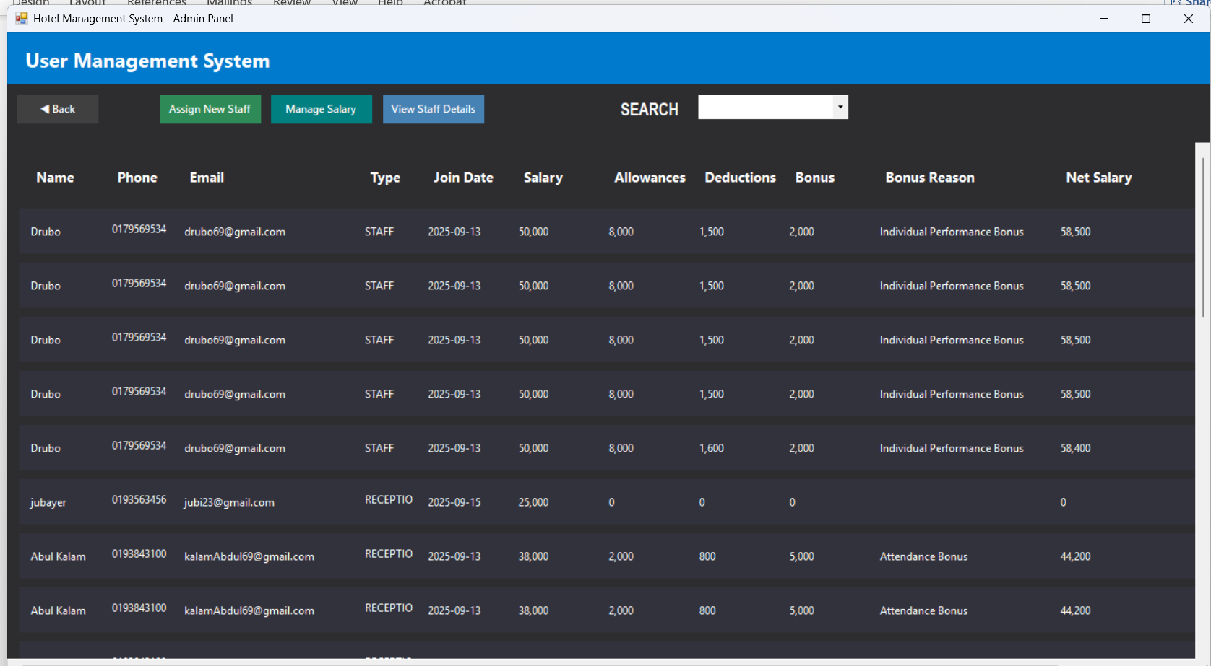

;

Assign Task:

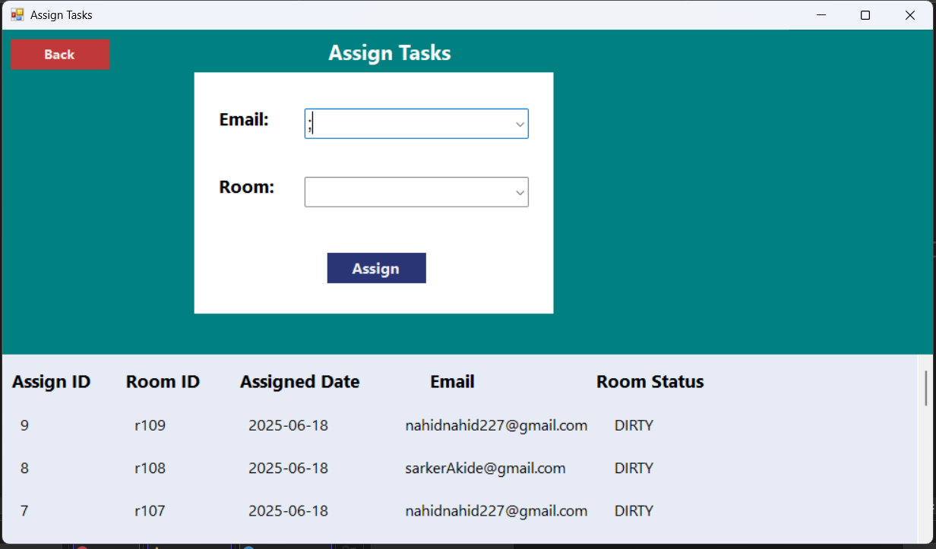

Revenue(**Daily**):

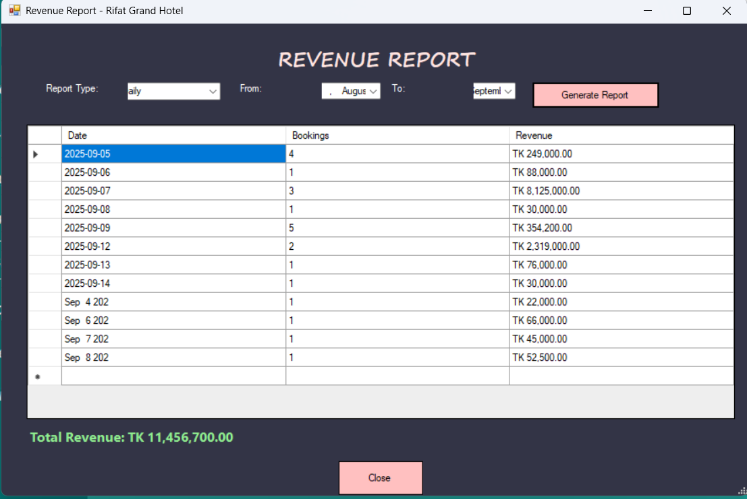

Revenue(**Monthly**):

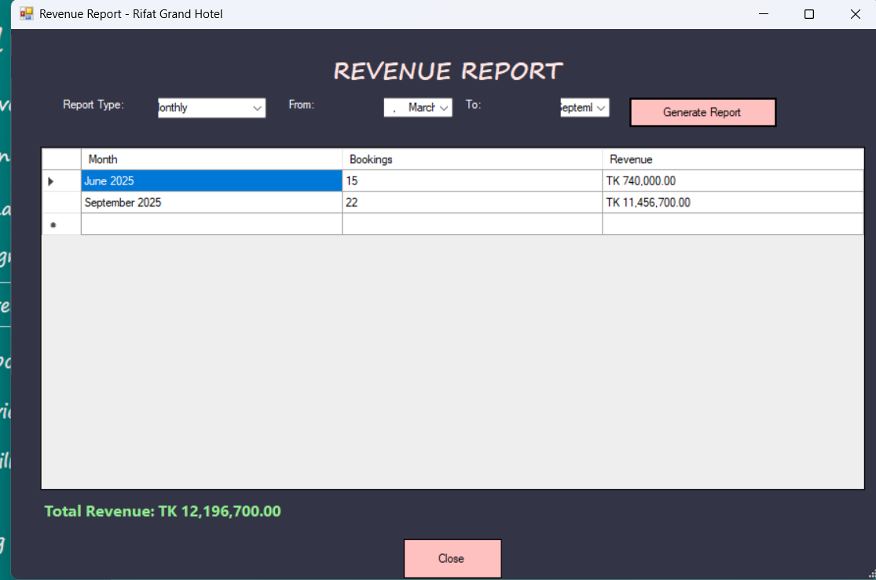\

Revenue(**Yearly**):

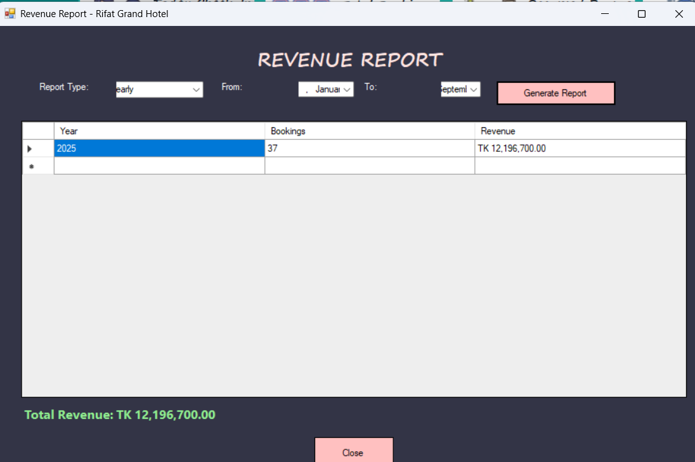

Reports :

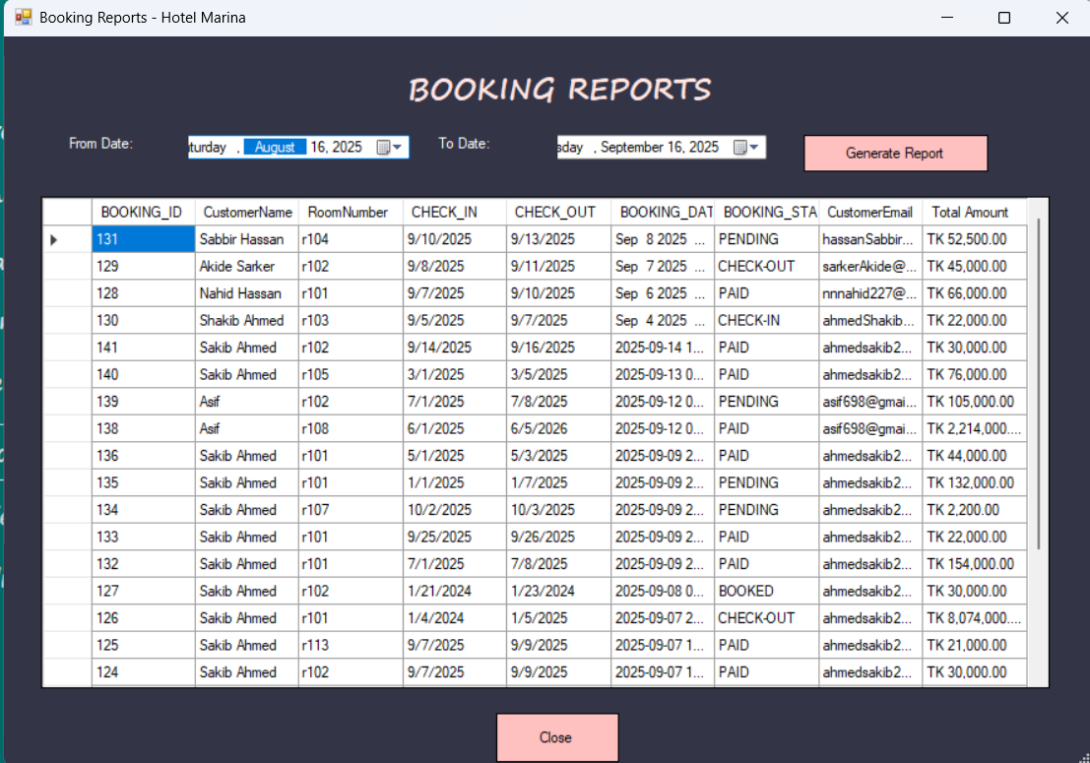

Reviews :

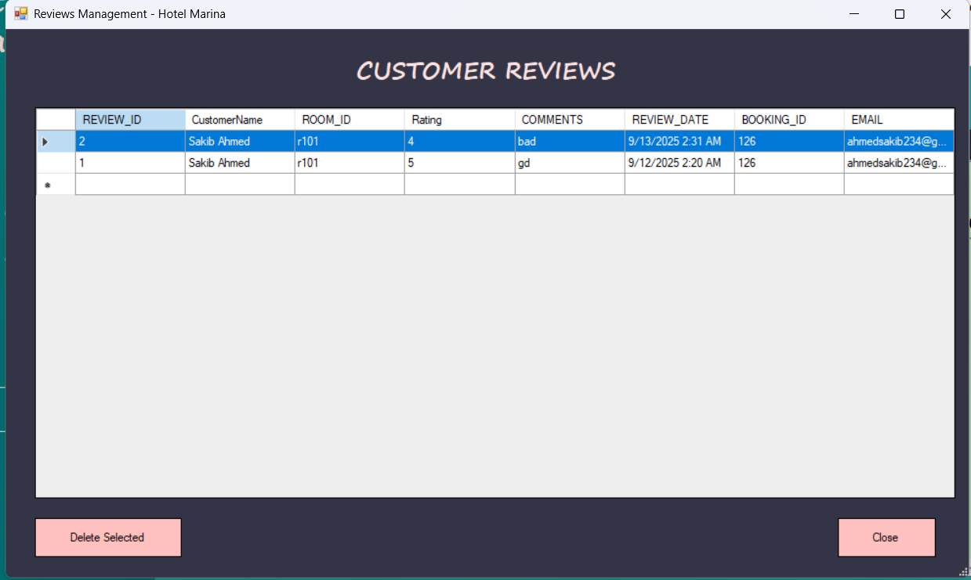

Facilities Form:

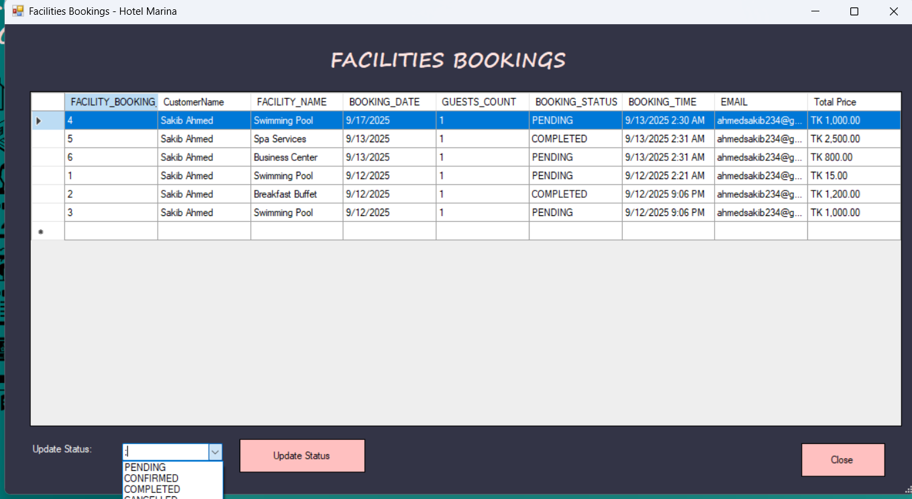

==================END ADMIN PANEL=================

CUSTOMER PANEL(ROOMS) :

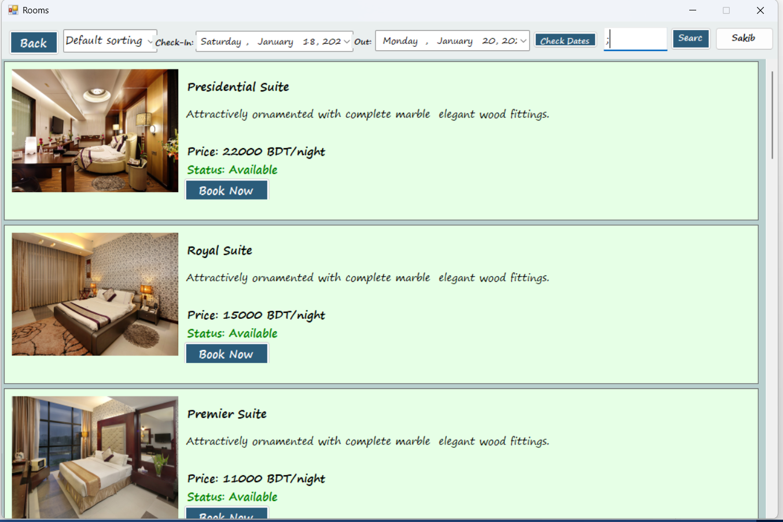

Rooms(**Sorting**):

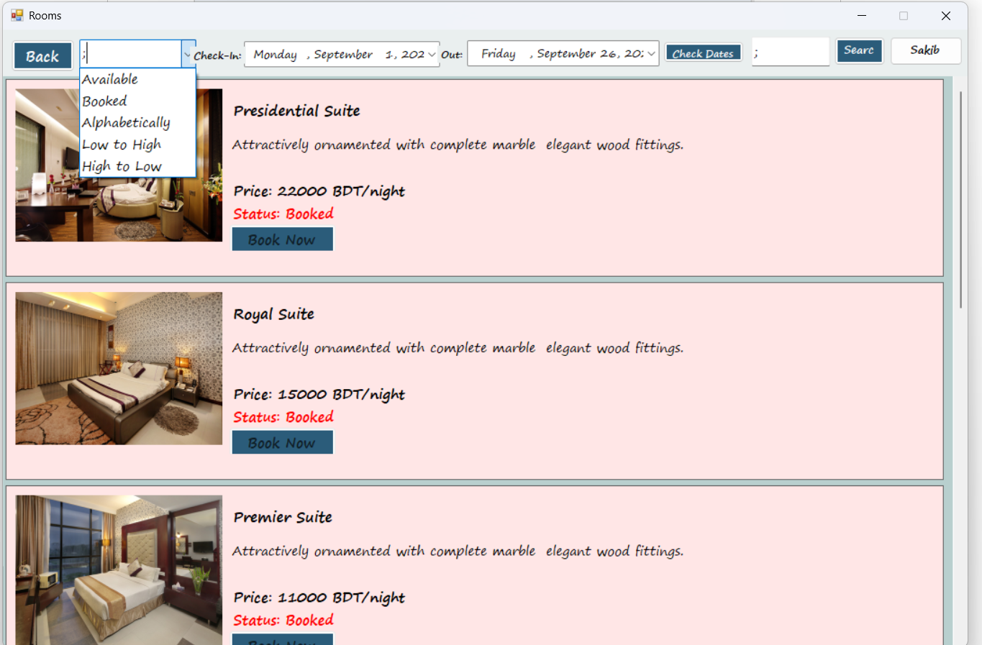

Booking Page:

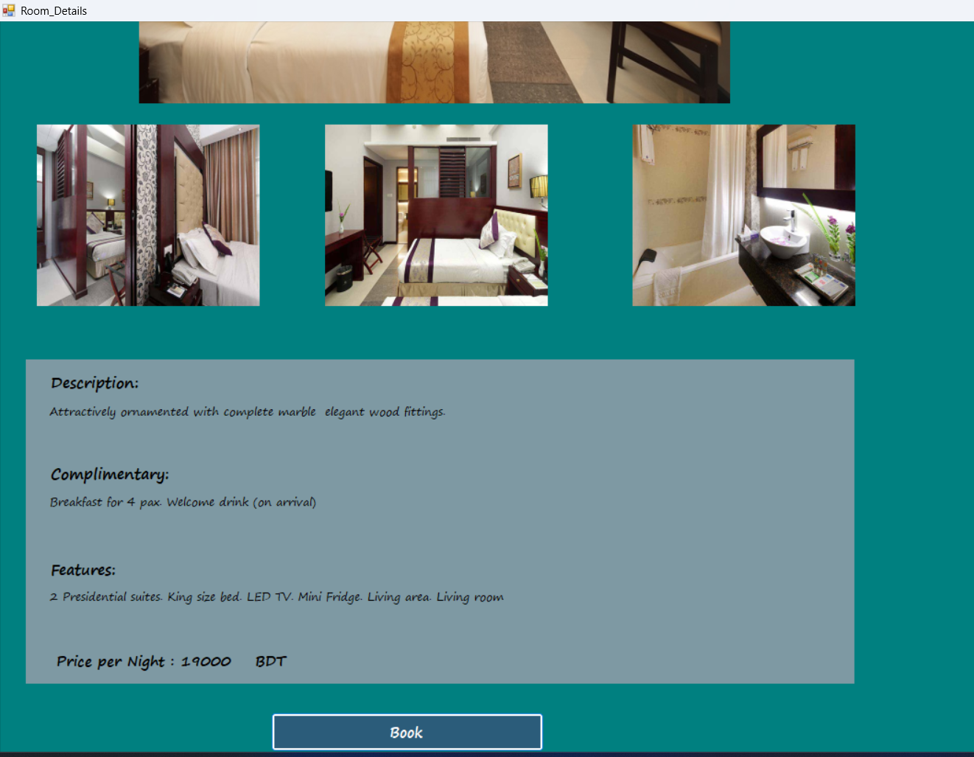

Confirm Booking :

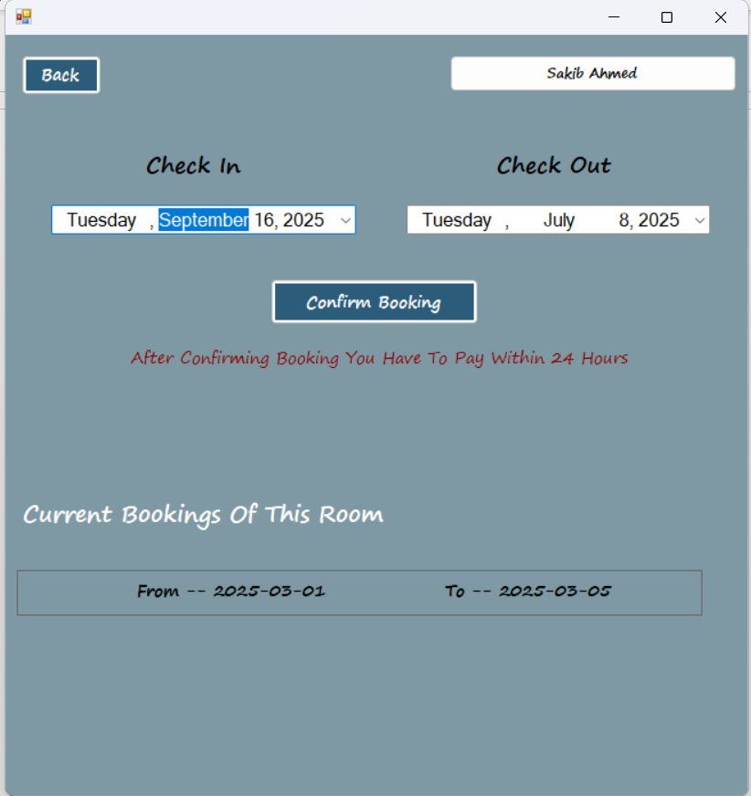

Multiple Payment Method :

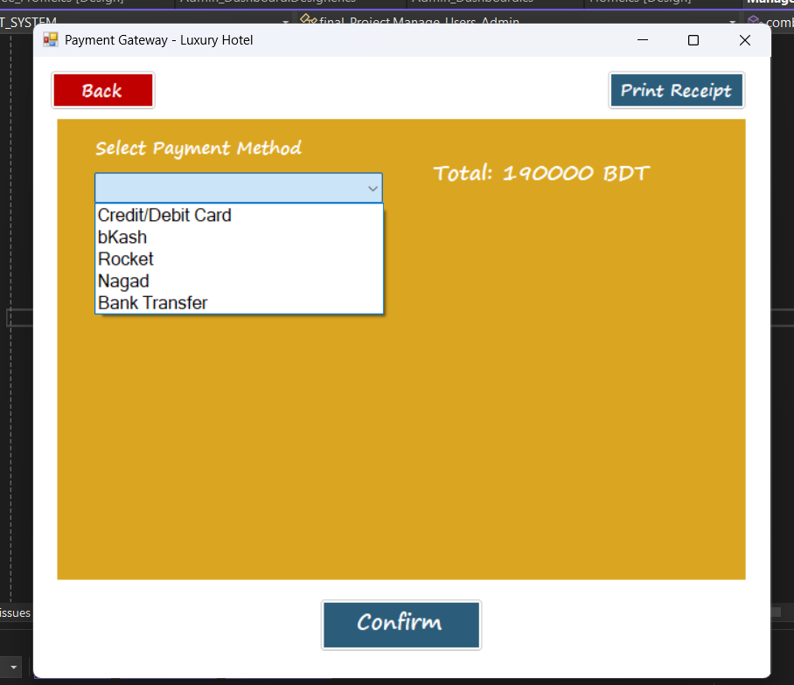

Multiple Payment Method (**Bkash OTP Generated**):

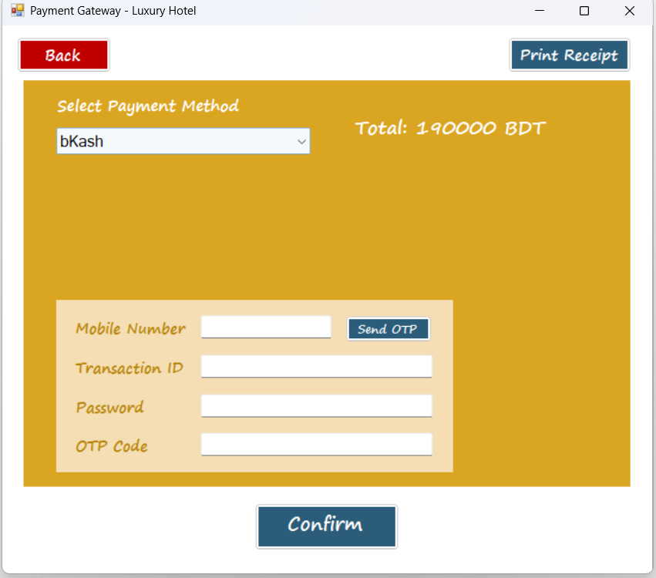

Multiple Payment Method **(Bank Transfer** ):

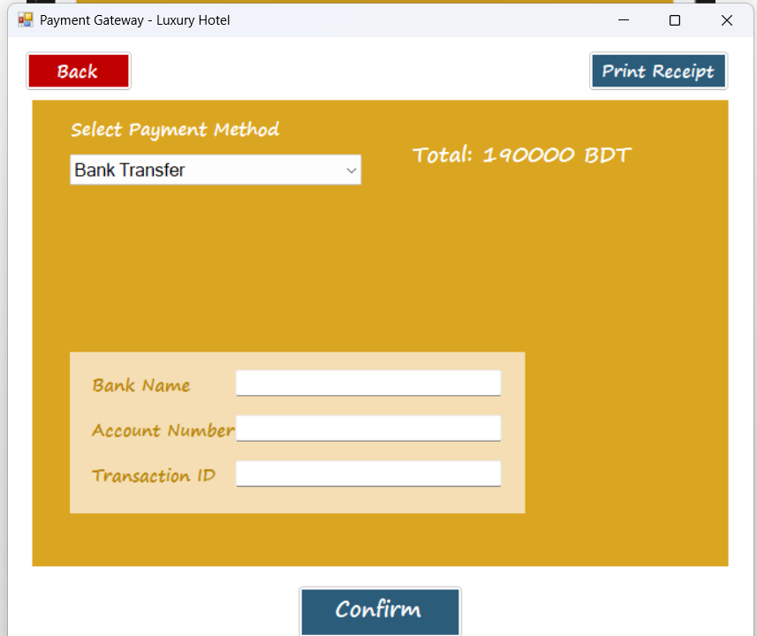

Print Receipt(**Choose Location):**

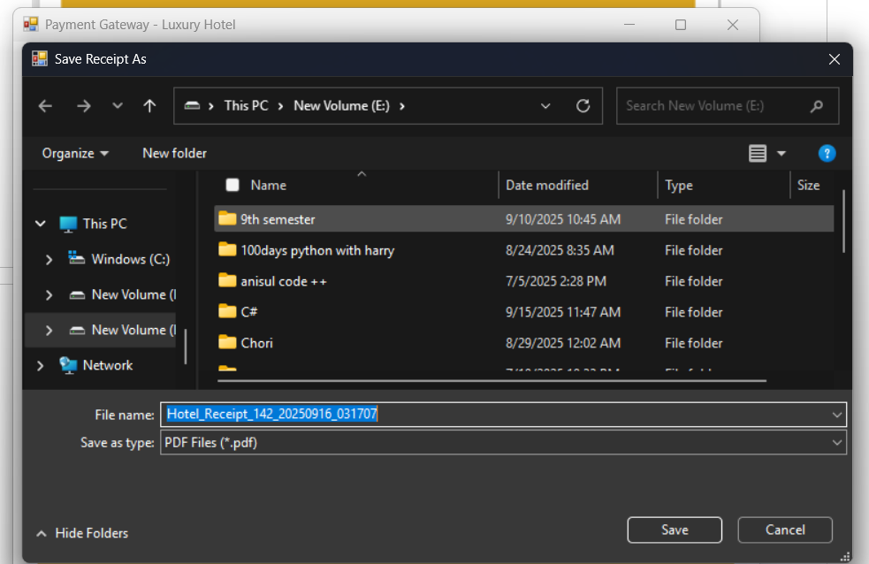

Print Receipt(Payment Receipt):

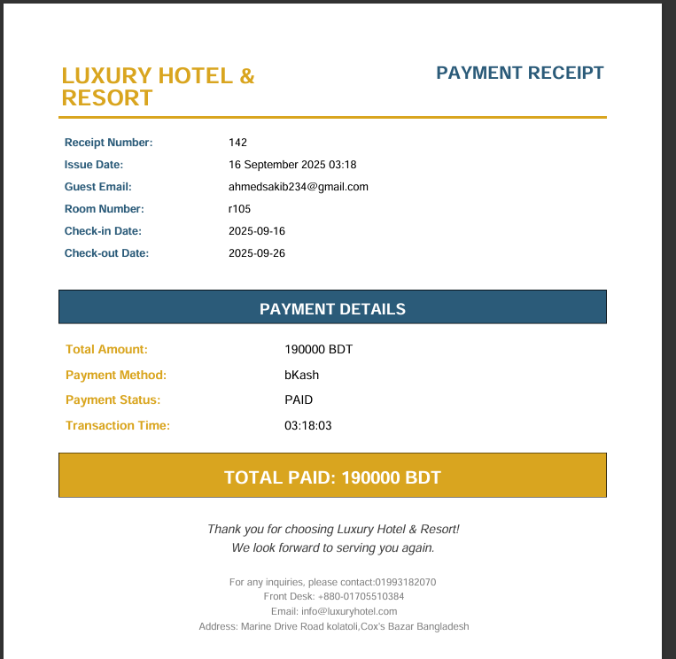

User Profile Dashboard & Booking History:

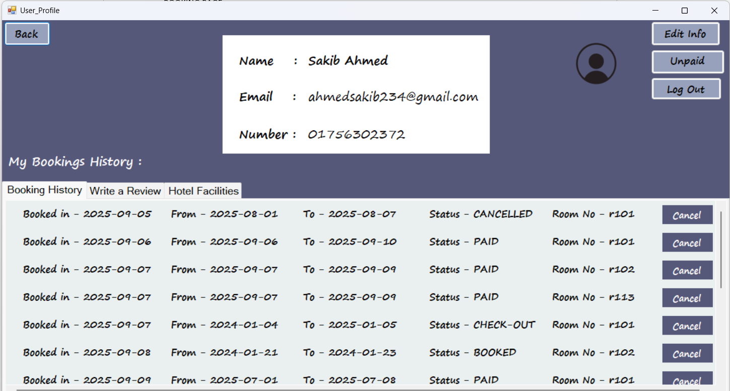

Review Option:

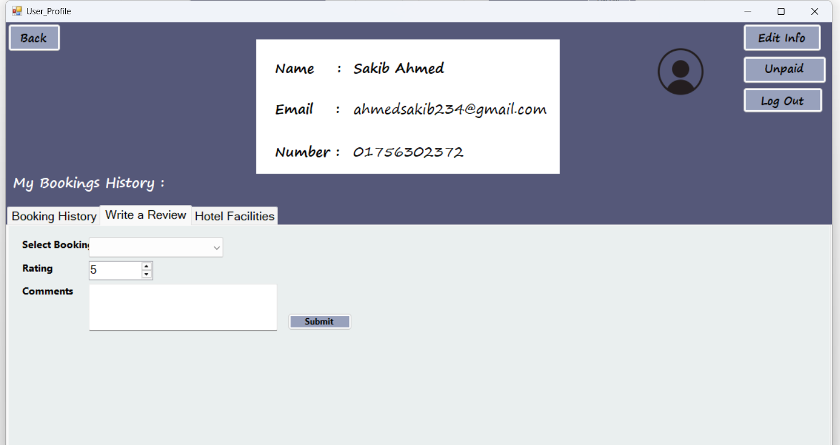

Facilities Add Option :

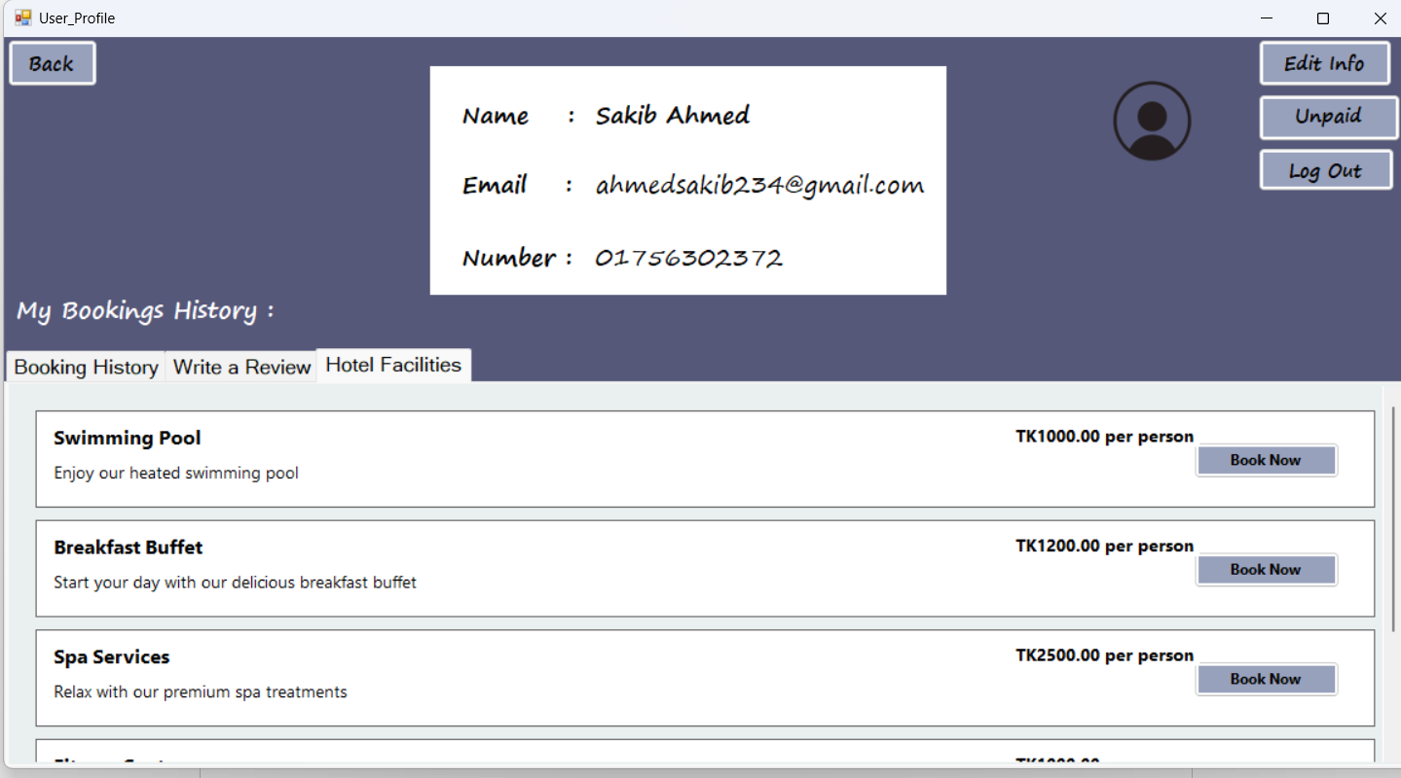

Edit Info Option:

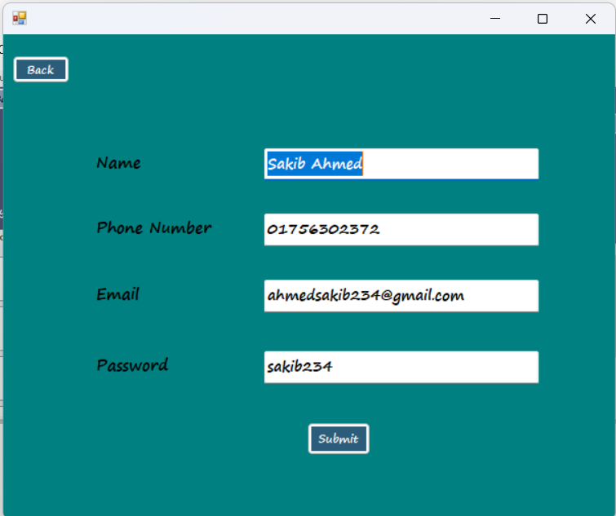

Unpaid Bill Option :’

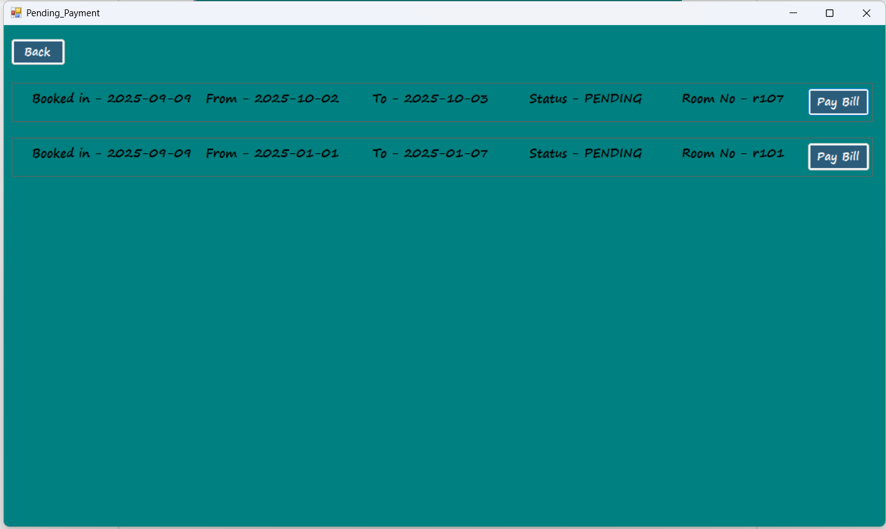

===================**CUSTOMER PANEL END**==================

RECEPTIONIST DASHBOARD :

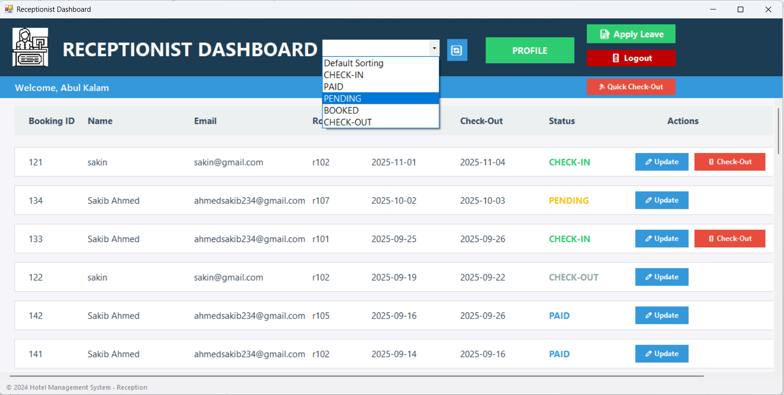

Receptionist Leave Form:

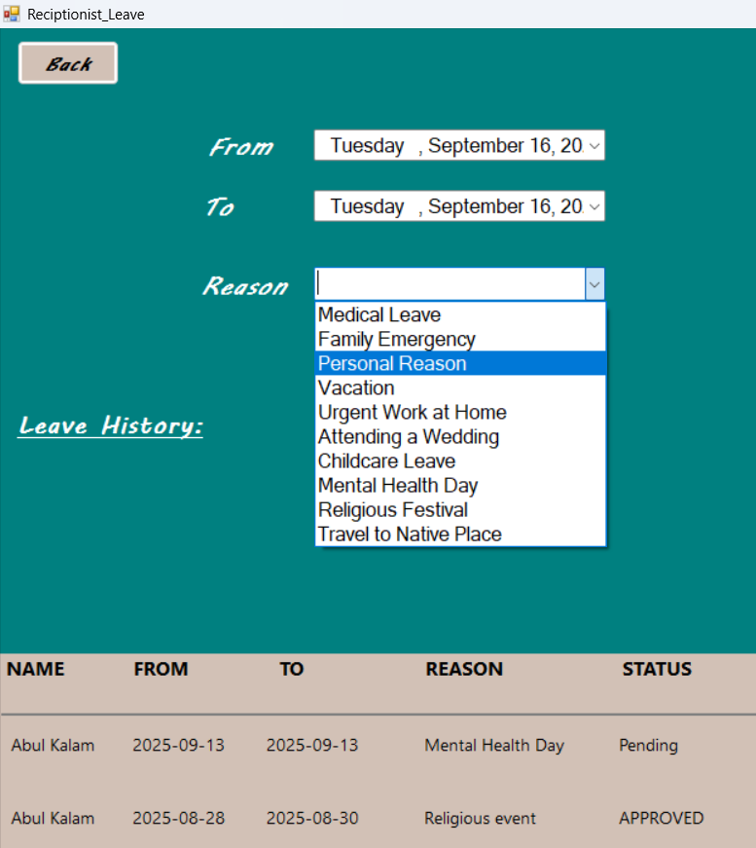

Receptionist Profile(**Additional Info** ):

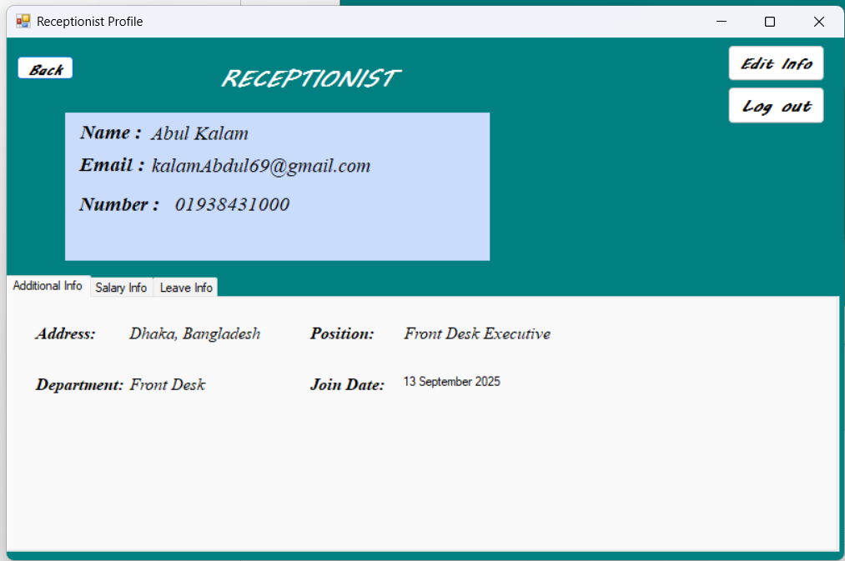

Receptionist Profile(**Salary Info** ):

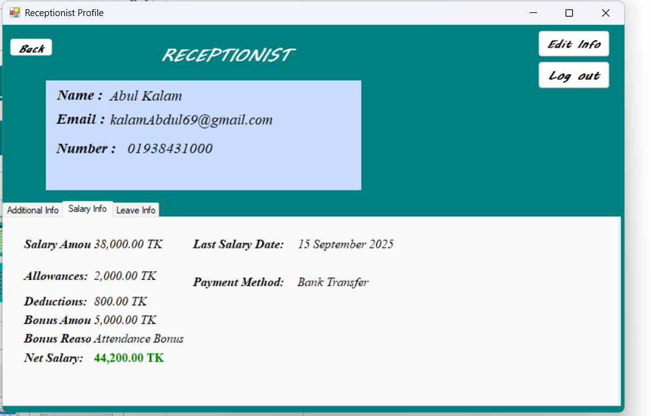

Receptionist Profile(Leave Info ):

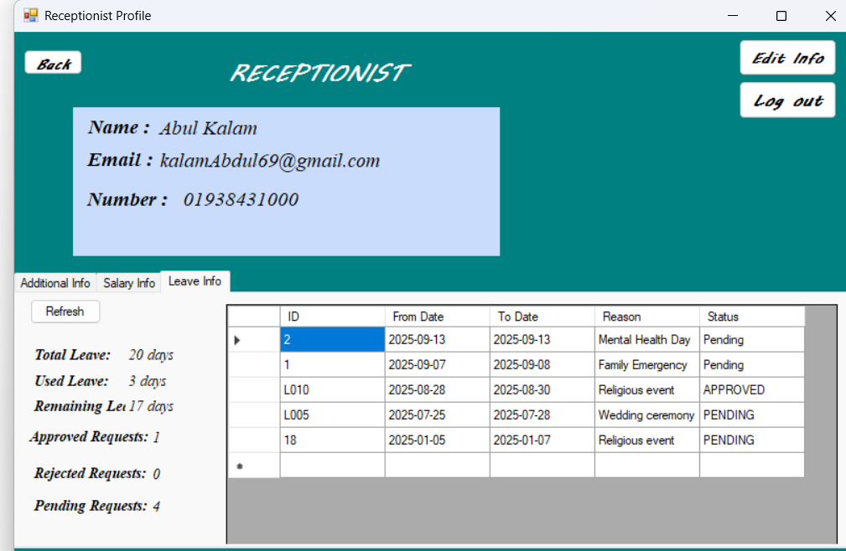

Edit Info :

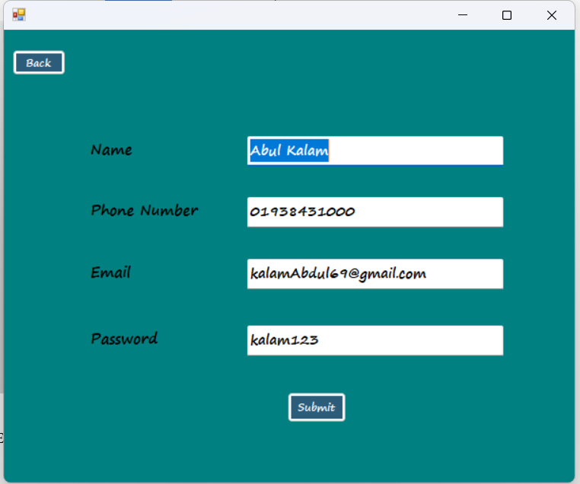

Sorting :

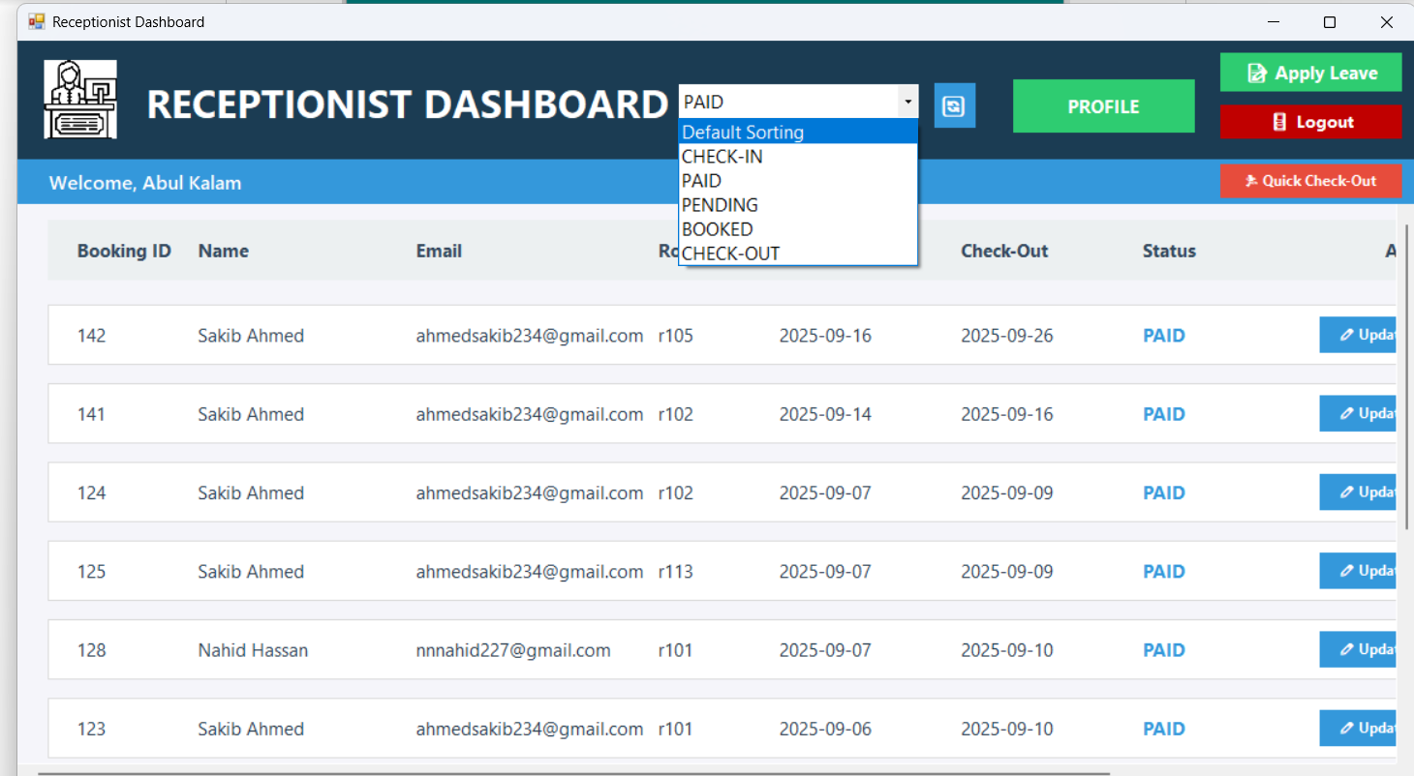

===============RECEPTIONIST PANEL END ======================

Staff Dashboard :

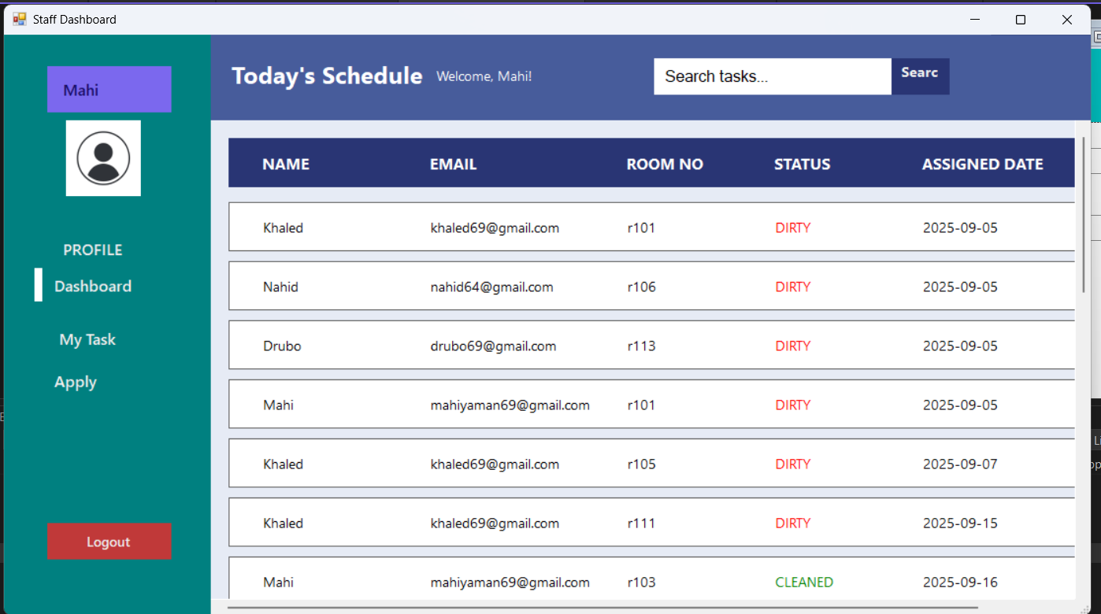

My Task :

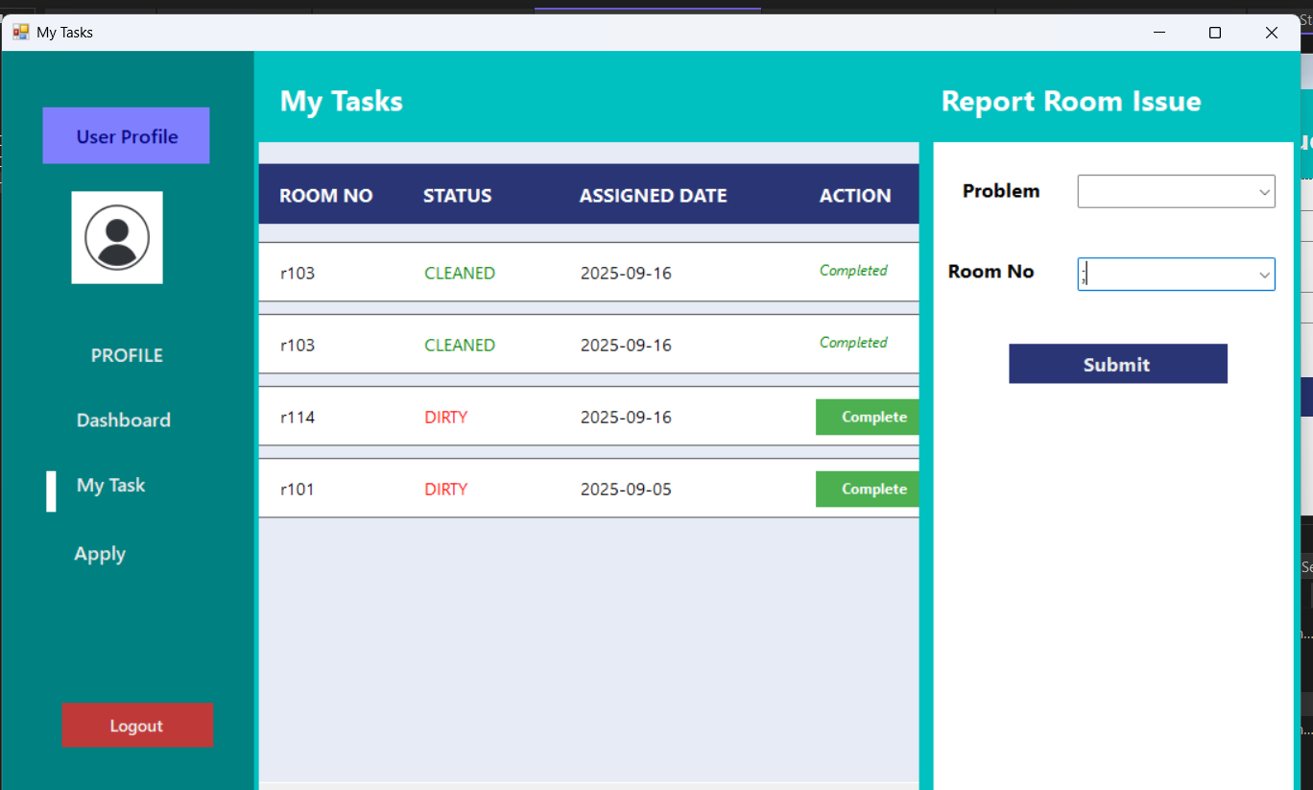

Apply Leave :

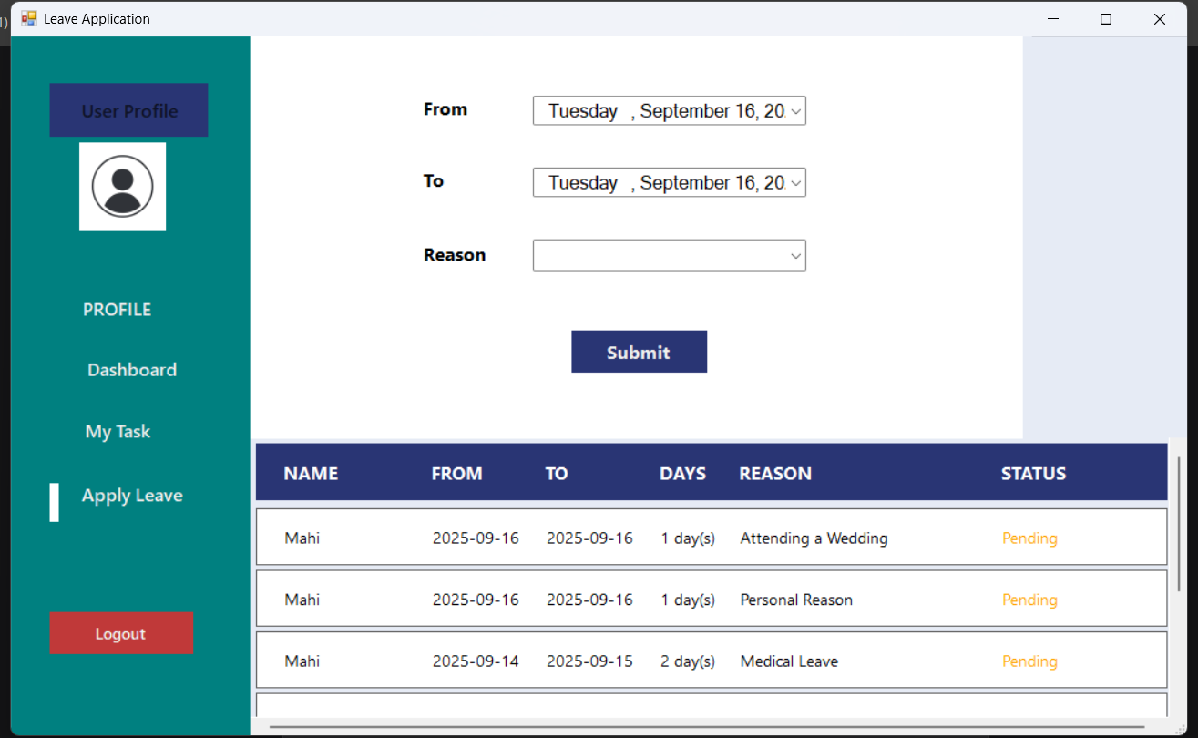

Staff Profile(**Additional Info**):

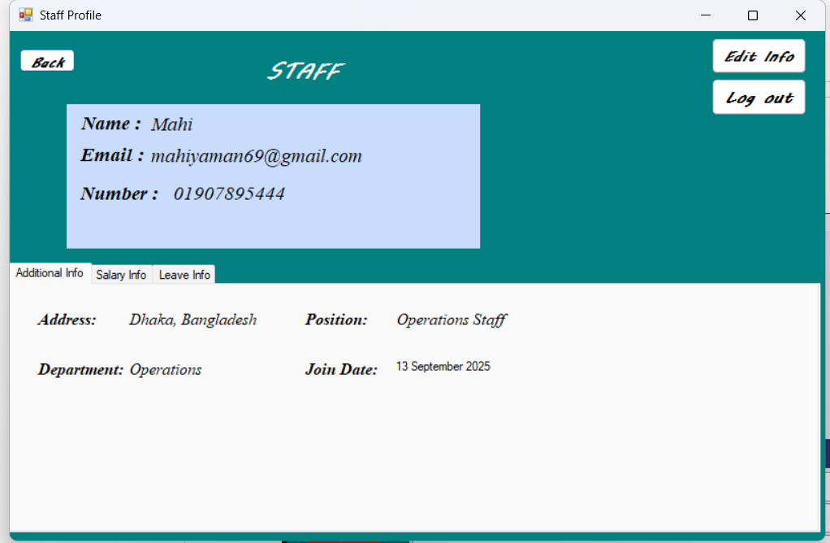

Staff Profile(**Salary Info**):

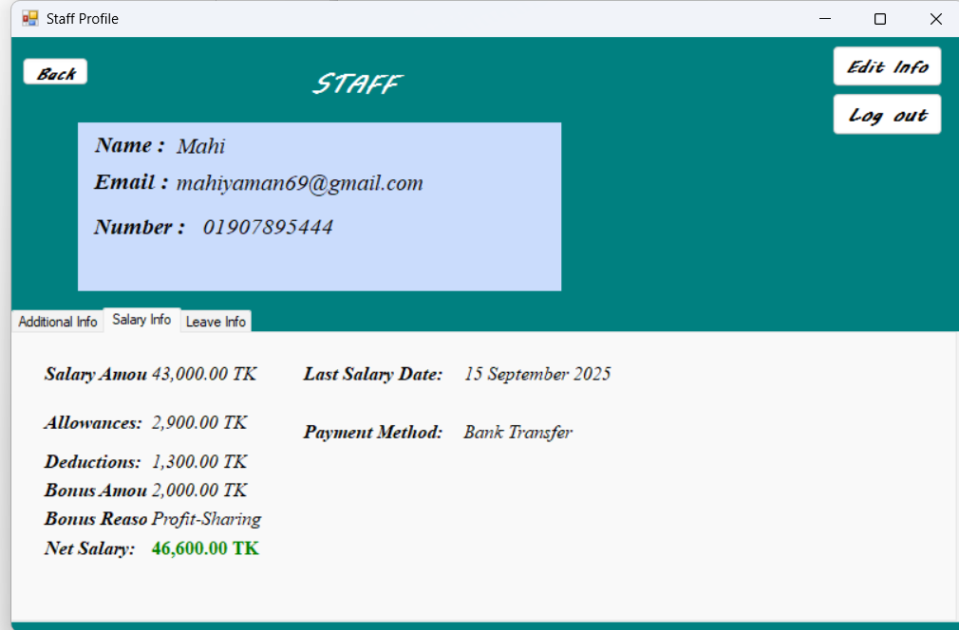

Leave Info:

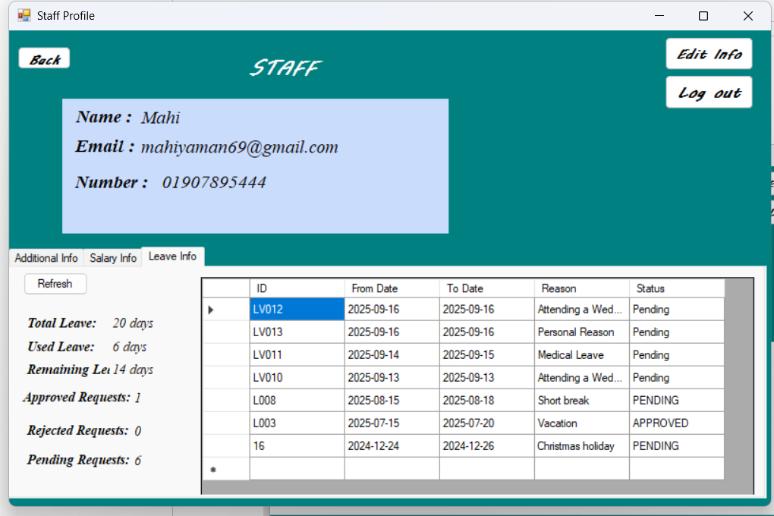

==================STAFF PANEL END ======================

QUERY (For Table Creation):

1.

**ROOM_TABLE**

**USER_TABLE**

CREATE TABLE ROOM_TABLE (

ROOM_ID NVARCHAR(50) NOT NULL,

TYPE NVARCHAR(50) NOT NULL,

PPN INT NOT NULL,

DESCRIPTION NVARCHAR(MAX) NULL,

PICTURE NVARCHAR(MAX) NULL,

COMPLIMENTARY NVARCHAR(MAX) NULL,

FEATURES NVARCHAR(MAX) NULL,

CONSTRAINT PK_ROOM_TABLE PRIMARY KEY (ROOM_ID)

);

CREATE TABLE USER_TABLE (

NAME NVARCHAR(50) NOT NULL,

PHONE_NUMBER NVARCHAR(50) NOT NULL,

EMAIL NVARCHAR(50) NOT NULL,

PASSWORD NVARCHAR(MAX) NOT NULL,

USER_TYPE NVARCHAR(50) NOT NULL,

ADDRESS NVARCHAR(255) NULL,

DEPARTMENT NVARCHAR(100) NULL,

POSITION NVARCHAR(100) NULL,

JOIN_DATE DATE NULL,

CONSTRAINT PK_USER_TABLE PRIMARY KEY (EMAIL)

);

**MAINTENANCEREQUESTS**

CREATE TABLE MaintenanceRequests (

M_ID NVARCHAR(50) NOT NULL,

ROOM_ID NVARCHAR(50) NOT NULL,

PROBLEM NVARCHAR(50) NOT NULL,

STATUS NVARCHAR(50) NOT NULL,

SUBMIT_DATE NVARCHAR(50) NOT NULL,

EMAIL NVARCHAR(50) NOT NULL,

CONSTRAINT PK_MaintenanceRequests PRIMARY KEY (M_ID),

CONSTRAINT FK_MaintenanceRequests_ROOM_TABLE FOREIGN KEY (ROOM_ID) REFERENCES ROOM_TABLE (ROOM_ID),

CONSTRAINT FK_MaintenanceRequests_USER_TABLE FOREIGN KEY (EMAIL) REFERENCES USER_TABLE (EMAIL)

);

**PAYMENT**

CREATE TABLE REVIEWS_TABLE (

REVIEW_ID INT NOT NULL,

BOOKING_ID NVARCHAR(50) NOT NULL,

EMAIL NVARCHAR(50) NOT NULL,

RATING INT NOT NULL,

COMMENTS NVARCHAR(MAX) NULL,

REVIEW_DATE DATETIME NULL,

CONSTRAINT PK_REVIEWS_TABLE PRIMARY KEY (REVIEW_ID),

CONSTRAINT FK_REVIEWS_TABLE_BOOKING_ID FOREIGN KEY (BOOKING_ID) REFERENCES BOOKING_TABLE(BOOKING_ID),

CONSTRAINT FK_REVIEWS_TABLE_EMAIL FOREIGN KEY (EMAIL) REFERENCES USER_TABLE(EMAIL)

);

CREATE TABLE ROOM_ASSIGNMENTS (

ASSIGNMENT_ID NVARCHAR(50) NOT NULL,

ROOM_ID NVARCHAR(50) NOT NULL,

ASSIGNED_DATE DATE NOT NULL,

EMAIL NVARCHAR(50) NOT NULL,

ROOM_STATUS NVARCHAR(50) NOT NULL,

CONSTRAINT PK_ROOM_ASSIGNMENTS PRIMARY KEY (ASSIGNMENT_ID),

CONSTRAINT FK_ROOM_ASSIGNMENTS_ROOM_TABLE FOREIGN KEY (ROOM_ID) REFERENCES ROOM_TABLE (ROOM_ID),

CONSTRAINT FK_ROOM_ASSIGNMENTS_USER_TABLE FOREIGN KEY (EMAIL) REFERENCES USER_TABLE (EMAIL)

);

**ROOM_ASSIGNMENTS**

CREATE TABLE PAYMENT (

P_ID NVARCHAR(50) NOT NULL,

BOOKING_ID NVARCHAR(50) NOT NULL,

CARD_NUMBER NVARCHAR(50) NOT NULL,

EXP_DATE DATE NOT NULL,

CODE NVARCHAR(50) NOT NULL,

BILL INT NOT NULL,

CONSTRAINT PK_PAYMENT PRIMARY KEY (P_ID),

CONSTRAINT FK_PAYMENT_BOOKINGS_TABLE FOREIGN KEY (BOOKING_ID) REFERENCES BOOKINGS_TABLE (BOOKING_ID)

);

**REVIEWS_TABLE**

**FACILITIES_BOOKING**

**LEAVE_REQUEST**

CREATE TABLE FACILITIES_BOOKING (

FACILITY_BOOKING_ID INT NOT NULL,

EMAIL NVARCHAR(50) NOT NULL,

FACILITY_NAME NVARCHAR(100) NOT NULL,

BOOKING_DATE DATETIME NOT NULL,

GUESTS_COUNT INT NOT NULL,

TOTAL_PRICE DECIMAL(10, 2) NOT NULL,

BOOKING_STATUS NVARCHAR(20) NULL,

BOOKING_TIME DATETIME NULL,

CONSTRAINT PK_FACILITIES_BOOKING PRIMARY KEY (FACILITY_BOOKING_ID),

CONSTRAINT FK_FACILITIES_EMAIL FOREIGN KEY (EMAIL) REFERENCES USER_TABLE (EMAIL)

);

CREATE TABLE LEAVE_REQUEST (

LEAVE_ID NVARCHAR(50) NOT NULL,

EMAIL NVARCHAR(50) NOT NULL,

FROM_DATE NVARCHAR(50) NOT NULL,

TO_DATE NVARCHAR(50) NOT NULL,

REASON NVARCHAR(50) NOT NULL,

STATUS NVARCHAR(50) NOT NULL,

CONSTRAINT PK_LEAVE_REQUEST_1 PRIMARY KEY (LEAVE_ID),

CONSTRAINT FK_LEAVE_REQUEST_USER_TABLE FOREIGN KEY (EMAIL) REFERENCES USER_TABLE (EMAIL)

);

CREATE TABLE dbo.BOOKINGS_TABLE (

BOOKING_ID NVARCHAR(50) NOT NULL,

EMAIL NVARCHAR(50) NOT NULL,

ROOM_ID NVARCHAR(50) NOT NULL,

CHECK_IN date NOT NULL,

CHECK_OUT date NOT NULL,

BOOKING_DATE NVARCHAR(50) NOT NULL,

BOOKING_STATUS NVARCHAR(50) NOT NULL,

TOTAL_AMOUNT decimal(10,2) NULL,

CONSTRAINT PK_BOOKINGS_TABLE PRIMARY KEY CLUSTERED (BOOKING_ID ASC),

CONSTRAINT FK_BOOKINGS_TABLE_ROOM_TABLE FOREIGN KEY (ROOM_ID) REFERENCES dbo.ROOM_TABLE(ROOM_ID),

CONSTRAINT FK_BOOKINGS_TABLE_USER_TABLE FOREIGN KEY (EMAIL) REFERENCES dbo.USER_TABLE(EMAIL)

);

**ADDITIONAL_PICTURES**

CREATE TABLE dbo.ADDITIONAL_PICTURES (

PICTURE_ID NVARCHAR(50) NOT NULL,

ROOM_ID NVARCHAR(50) NOT NULL,

IMAGE_1 NVARCHAR(max) NULL,

IMAGE_2 NVARCHAR(max) NULL,

IMAGE_3 NVARCHAR(max) NULL,

IMAGE_4 NVARCHAR(50) NULL,

IMAGE_5 NVARCHAR(50) NULL,

CONSTRAINT PK_ADDITIONAL_PICTURES PRIMARY KEY CLUSTERED (PICTURE_ID ASC),

CONSTRAINT FK_ADDITIONAL_PICTURES_ROOM_TABLE FOREIGN KEY (ROOM_ID)

REFERENCES dbo.ROOM_TABLE (ROOM_ID)

);

**BOOKINGS_TABLE**

**EMPLOYEE_SALARY**

CREATE TABLE EMPLOYEE_SALARY (

SALARY_ID INT NOT NULL,

EMPLOYEE_EMAIL NVARCHAR(50) NOT NULL,

SALARY_AMOUNT DECIMAL(10, 2) NOT NULL,

PAYMENT_DATE DATE NOT NULL,

PAYMENT_METHOD NVARCHAR(50) NULL,

ALLOWANCES DECIMAL(10, 2) NULL,

DEDUCTIONS DECIMAL(10, 2) NULL,

BONUS_AMOUNT DECIMAL(10, 2) NULL,

BONUS_REASON NVARCHAR(100) NULL,

CONSTRAINT PK_EMPLOYEE_SALARY PRIMARY KEY (SALARY_ID),

CONSTRAINT FK_EMPLOYEE_SALARY_USER_TABLE FOREIGN KEY (EMPLOYEE_EMAIL) REFERENCES USER_TABLE (EMAIL)

);

**System Functionalities with SQL Queries**

***ADMIN DASHBOARD:***

**1.LOAD ROOMS**

SELECT RA.ROOM_ID, SA.NAME

FROM BOOKINGS_TABLE RA

JOIN USER_TABLE SA ON RA.EMAIL = SA.EMAIL

WHERE RA.BOOKING_STATUS = 'CHECK-IN'

**2. LOAD BOOKING HISTORY**

SELECT RA.ROOM_ID, RA.BOOKING_DATE, SA.NAME

FROM BOOKINGS_TABLE RA

JOIN USER_TABLE SA ON RA.EMAIL = SA.EMAIL

**3**.**LOAD DASHBOARD COUNTS:**

-- Total Bookings

SELECT COUNT(*) FROM BOOKINGS_TABLE

-- Occupied Rooms

SELECT COUNT(*) FROM BOOKINGS_TABLE WHERE BOOKING_STATUS = 'CHECK-IN'

-- Today's Check-Ins

SELECT COUNT(*) FROM BOOKINGS_TABLE WHERE CAST(CHECK_IN AS DATE) = CAST(GETDATE() AS DATE)

-- Today's Revenue

SELECT ISNULL(SUM(DATEDIFF(DAY, B.CHECK_IN, B.CHECK_OUT) * R.PPN), 0)

FROM BOOKINGS_TABLE B

JOIN ROOM_TABLE R ON B.ROOM_ID = R.ROOM_ID

WHERE CAST(B.BOOKING_DATE AS DATE) = CAST(GETDATE() AS DATE)

**4**.**LOAD REVIEWS**

SELECT

R.REVIEW_ID,

U.NAME AS CustomerName,

B.ROOM_ID,

R.RATING,

R.COMMENTS,

R.REVIEW_DATE,

B.BOOKING_ID,

U.EMAIL

FROM REVIEWS_TABLE R

JOIN USER_TABLE U ON R.EMAIL = U.EMAIL

JOIN BOOKINGS_TABLE B ON R.BOOKING_ID = B.BOOKING_ID

ORDER BY R.REVIEW_DATE DESC

**5.LOAD FACILITY BOOKINGS**

SELECT

FB.FACILITY_BOOKING_ID,

U.NAME AS CustomerName,

FB.FACILITY_NAME,

FB.BOOKING_DATE,

FB.GUESTS_COUNT,

FB.TOTAL_PRICE,

FB.BOOKING_STATUS,

FB.BOOKING_TIME,

U.EMAIL

FROM FACILITIES_BOOKING FB

JOIN USER_TABLE U ON FB.EMAIL = U.EMAIL

ORDER BY FB.BOOKING_DATE DESC

**6.REVENUE REPORT**

SELECT

CONCAT(DATENAME(MONTH, B.BOOKING_DATE), ' ', YEAR(B.BOOKING_DATE)) AS Month,

SUM(DATEDIFF(DAY, B.CHECK_IN, B.CHECK_OUT) * R.PPN) AS Revenue,

COUNT(*) AS Bookings

FROM BOOKINGS_TABLE B

JOIN ROOM_TABLE R ON B.ROOM_ID = R.ROOM_ID

WHERE B.BOOKING_DATE BETWEEN @StartDate AND @EndDate

GROUP BY YEAR(B.BOOKING_DATE), MONTH(B.BOOKING_DATE), DATENAME(MONTH, B.BOOKING_DATE)

ORDER BY YEAR(B.BOOKING_DATE), MONTH(B.BOOKING_DATE)

**7.BOOKING REPORT QUERY**

SELECT

B.BOOKING_ID,

U.NAME AS CustomerName,

B.ROOM_ID AS RoomNumber,

B.CHECK_IN,

B.CHECK_OUT,

B.BOOKING_DATE,

B.BOOKING_STATUS,

DATEDIFF(DAY, B.CHECK_IN, B.CHECK_OUT) * R.PPN AS TotalAmount,

B.EMAIL AS CustomerEmail

FROM BOOKINGS_TABLE B

JOIN USER_TABLE U ON B.EMAIL = U.EMAIL

JOIN ROOM_TABLE R ON B.ROOM_ID = R.ROOM_ID

WHERE B.BOOKING_DATE BETWEEN @FromDate AND @ToDate

ORDER BY B.BOOKING_DATE DESC

**User Authentication query :**

SELECT PASSWORD, USER_TYPE

FROM USER_TABLE

WHERE EMAIL = @Email

**CUSTOMER :**

**REGISTRATION FORM :**

**1.MAIN INSERT QUERY :**

INSERT INTO USER_TABLE (NAME, PHONE_NUMBER, EMAIL, PASSWORD, USER_TYPE)

VALUES (@Name, @Phone, @Email, @Password, 'CUSTOMER')

**2.CHECK EMAIL EXISTENCE(BEFORE REGISTRATION)**

SELECT COUNT(*) FROM USER_TABLE WHERE EMAIL = @Email

**3.GET USER DETAILS AFTER REGISTRATION FORM**

SELECT USER_ID, NAME, EMAIL, USER_TYPE FROM USER_TABLE WHERE EMAIL = @Email

**4.GET ROOM DETAILS :**

SELECT TYPE, PPN, DESCRIPTION, PICTURE, COMPLIMENTARY, FEATURES

FROM ROOM_TABLE

WHERE ROOM_ID = @RoomId

**5.GET ADDITIONAL ROOM P;ICTURES** :

SELECT IMAGE_1, IMAGE_2, IMAGE_3

FROM ADDITIONAL_PICTURES

WHERE ROOM_ID = @RoomId

**6.GET USER INFORMATION**

SELECT NAME

FROM USER_TABLE

WHERE EMAIL = @Email

**7.GET ALL ROOMS**

SELECT ROOM_ID, TYPE, PPN, DESCRIPTION, PICTURE FROM ROOM_TABLE

**8.CHECK ROOM AVAILABILITY**

SELECT COUNT(*)

FROM BOOKINGS_TABLE

WHERE ROOM_ID = @RoomId

AND BOOKING_STATUS IN ('PAID', 'BOOKED', 'CHECK-IN', 'PENDING', 'Confirmed', 'Checked-In')

AND (

(CHECK_IN <= @CheckOut AND CHECK_OUT >= @CheckIn)

)

**9.GET USER INFORMATION**

SELECT NAME FROM USER_TABLE WHERE EMAIL = @Email

**10.SEARCH ROOM BY TYPE**

SELECT ROOM_ID, TYPE, PPN, DESCRIPTION, PICTURE

FROM ROOM_TABLE

WHERE TYPE LIKE @SearchText

**11.GET ROOM PRICE (PPN)**

SELECT PPN FROM ROOM_TABLE WHERE ROOM_ID = @RoomId

**12.UPDATE BOOKING STATUS TO PAID**

UPDATE BOOKINGS_TABLE SET BOOKING_STATUS='PAID' WHERE BOOKING_ID = @BookingId

**13.INSERT PAYMENT METHOD**

INSERT INTO PAYMENT (P_ID, BOOKING_ID, CARD_NUMBER, EXP_DATE, CODE, BILL)

VALUES (@P_ID, @BOOKING_ID, @CARD_NUMBER, @EXP_DATE, @CODE, @BILL)

**14.GET NEXT PAYMENT METHOD ID**

SELECT ISNULL(MAX(P_ID), 0) + 1 FROM PAYMENT

**15.FIND ROOM ID BOOKING**

SELECT ROOM_ID FROM BOOKINGS_TABLE WHERE BOOKING_ID = @BookingId

**STAFF:**

**1.GET USER INFORMATION**

SELECT NAME FROM USER_TABLE WHERE EMAIL = @email

**2.LOAD ROOM ASSIGHNMENTS(ALL STAFF)**

SELECT RA.ASSIGNMENT_ID, RA.ROOM_ID, RA.ASSIGNED_DATE, RA.EMAIL, RA.ROOM_STATUS, UT.NAME

FROM ROOM_ASSIGNMENTS RA

JOIN USER_TABLE UT ON RA.EMAIL = UT.EMAIL

WHERE (@nameFilter = '' OR UT.NAME LIKE @nameFilter)

**3.SEARCH ROOM ASSIGHNMENTS BY NAME**

SELECT RA.ASSIGNMENT_ID, RA.ROOM_ID, RA.ASSIGNED_DATE, RA.EMAIL, RA.ROOM_STATUS, UT.NAME

FROM ROOM_ASSIGNMENTS RA

JOIN USER_TABLE UT ON RA.EMAIL = UT.EMAIL

WHERE UT.NAME LIKE @nameFilter

**4.INSERT LAVE REQUEST :**

INSERT INTO LEAVE_REQUEST (LEAVE_ID, EMAIL, FROM_DATE, TO_DATE, REASON, STATUS)

VALUES (@Id, @Email, @FromDate, @ToDate, @Reason, 'Pending')

**5.LOAD LEAVE HISTORY:**

SELECT RA.FROM_DATE, RA.TO_DATE, RA.REASON, RA.STATUS, UT.NAME

FROM LEAVE_REQUEST RA

JOIN USER_TABLE UT ON RA.EMAIL = UT.EMAIL

WHERE RA.EMAIL = @Email

ORDER BY RA.FROM_DATE DESC

**6.LOAD MY TASKS ;**

SELECT ROOM_ID, ROOM_STATUS, ASSIGNED_DATE

FROM ROOM_ASSIGNMENTS

WHERE EMAIL = @myEmail

ORDER BY ASSIGNED_DATE DESC

**7.UPDATE TASKS STATUS TO COMPLETED ;**

UPDATE ROOM_ASSIGNMENTS

SET ROOM_STATUS = 'CLEANED'

WHERE ROOM_ID = @roomId AND EMAIL = @email

**8.VERIFY TASK OWNERSHIP:**

SELECT COUNT(*)

FROM ROOM_ASSIGNMENTS

WHERE ROOM_ID = @roomId AND EMAIL = @email

**9.SUBMIT MAINTENANCE REQUEST :**

INSERT INTO MaintenanceRequests (M_ID, ROOM_ID, PROBLEM, STATUS, SUBMIT_DATE, EMAIL)

VALUES (@Id, @RoomId, @Problem, 'Pending', @Today, @Email)

**10.GET NEXT MAINTENANCE REQUEST ID:**

SELECT ISNULL(MAX(CAST(SUBSTRING(M_ID, 3, LEN(M_ID)) AS INT)), 0) + 1

FROM MaintenanceRequests

**RECEPTIONIST :**

**1.GET RECEPTIONIST INFORMATION**

SELECT NAME FROM USER_TABLE WHERE EMAIL = @Email

**2.LOAD BOOKING WITH FILTERING**

SELECT RA.BOOKING_ID, RA.EMAIL, RA.ROOM_ID, RA.CHECK_IN, RA.CHECK_OUT,

RA.BOOKING_STATUS, UT.NAME

FROM BOOKINGS_TABLE RA

JOIN USER_TABLE UT ON RA.EMAIL = UT.EMAIL

WHERE 1=1

**3.CHECK OUT GUEST:**

UPDATE BOOKINGS_TABLE

SET BOOKING_STATUS = 'CHECK-OUT'

WHERE BOOKING_ID = @BookingId

**ADDITIONAL QUERY:**

**1.GET STAFF EMAILS**

SELECT EMAIL FROM USER_TABLE WHERE USER_TYPE = 'STAFF'

**2.GENERATE NEW ASSIGHNMENTS ID**

SELECT ISNULL(MAX(CAST(ASSIGNMENT_ID AS INT)), 0) + 1

FROM ROOM_ASSIGNMENTS

WHERE ISNUMERIC(ASSIGNMENT_ID) = 1

**3.INSERT ROOM ASSIGHNMENTS :**

INSERT INTO ROOM_ASSIGNMENTS

(ASSIGNMENT_ID, ROOM_ID, ASSIGNED_DATE, EMAIL, ROOM_STATUS)

VALUES (@id, @room, @date, @email, @status)

**4.LEAVE STATISTICS**

SELECT

COUNT(*) as TotalRequests,

SUM(CASE WHEN STATUS = 'APPROVED' THEN 1 ELSE 0 END) as ApprovedRequests,

SUM(CASE WHEN STATUS = 'PENDING' THEN 1 ELSE 0 END) as PendingRequests,

SUM(CASE WHEN STATUS = 'REJECTED' THEN 1 ELSE 0 END) as RejectedRequests,

SUM(CASE WHEN STATUS = 'APPROVED' THEN DATEDIFF(day, FROM_DATE, TO_DATE) + 1 ELSE 0 END) as TotalLeaveDays

FROM LEAVE_REQUEST

WHERE EMAIL = @Email

**5.GET USER VERIFICATION DATA :**

CREATE PROCEDURE sp_GetUserVerificationData

@Email NVARCHAR(255)

AS

BEGIN

SELECT

PHONE_NUMBER,

USER_ID,

SECURITY_QUESTION -- Optional: Add for additional security

FROM USER_TABLE

WHERE EMAIL = @Email

END

**6.UPDATE PASSWORD**

CREATE PROCEDURE sp_GetUserVerificationData

@Email NVARCHAR(255)

AS

BEGIN

SELECT

PHONE_NUMBER,

USER_ID,

SECURITY_QUESTION -- Optional: Add for additional security

FROM USER_TABLE

WHERE EMAIL = @Email

END